**SURVEILLANCE DRONE**

**BACHELOR OF TECHNOLOGY**

**in**

**ELECTRICAL AND ELECTRONICS ENGINEERING**

**By**

**S. DILEEP KUMAR 20L31A02F2**

**N. PAVANI 20L31A02D1**

**P. SAI ROHAN 20L31A02E1**

**SK. KHWAJA MOINUDDIN 21L35A0223**

**Under the Guidance of**

Dr. K. K. Deepika

Assistant Professor



**DEPARTMENT OF ELECTRICAL AND ELECRONICS ENGINEERING**

**VIGNAN’S INSTITUTE OF INFORMATION TECHNOLOGY**

(Autonomous)

(Affiliated to JNTUGV) Approved by AICTE, New Delhi - Accredited by NBA & NAAC ISO 9001:2008, ISO 14001:2004, OHSAS 18001:2007 Certified Institution VISAKHAPATNAM -530 049

**2024**

# Acknowledgement

The satisfaction that accompanies the successful completion of the task would be incomplete without the mention of the people who made it possible, whose constant guidance and encouragement crown all the efforts with success.

I would extend my sincere gratitude towards my supervisor **Dr. K. K. Deepika**, Assistant Professor (EEE) who has always been a constant motivation and guiding factor throughout the project time in and out as well. It has been a great pleasure for me to get an opportunity to work under him/her and complete the project successfully.

My hearty thanks to **Dr. P. Sekhar**, Head of the Department of EEE for his great support & encouragement for providing all facilities and environment needed to carry out this dissertation work.

I also like to express my thanks to all Faculty Members of Department of EEE for imparting knowledge to me and supporting me.

My hearty thanks to **Dr. J. Sudhakar**, Principal for his support and encouragement and for his valuable suggestions.

My heartly thanks to **Mr. N. Srikanth**, CEO and **Dr. V. Madhusudhana Rao**, Rector for making me comfort throughout my dissertation work with their intellectual management skills in the institute.

I would like to express my gratitude from bottom of the heart to **Dr. L. Rattaiah**, Chairman of the Vignan’s Group of Institutions and **Mr. L. Sri Krishnadevaraya**, Vice-chairman of Vignan’s Group of Institutions for providing all necessary facilities and congenial learning process environment in the institute.

Finally, I take this opportunity to thank all the people who helped me directly or indirectly in the completion of the dissertation work and for their timely encouragement and helpful services.

# ABSTRACT

Surveillance drones that use a flight controller are an example of how unmanned aerial systems (UAS) technology has advanced. Traditional surveillance techniques, such as Closed-Circuit Television (CCTV) systems, have limits in today's world when it comes to providing constant and thorough monitoring, particularly over large or constantly changing settings. Although flexible, manual drone operations are prone to human mistake, which could compromise the effectiveness of security protocols.

Although there have been developments, more study is still needed to ensure that real-time data processing and ethical considerations are seamlessly integrated with autonomous surveillance drones. The goals of autonomous surveillance drones are to enhance their operational versatility and surveillance capabilities by integrating quadcopter cameras for live streaming and recording, implementing manual flight control via a transmitter, integrating telemetry modules for autopilot functionality, allowing the selection of multiple flight paths, and more.The thesis examines a number of tests, including as payload, stability, speed, and altitude tests, that are carried out to evaluate the surveillance drone's performance and compatibility. The findings and conversations underscore the proficient execution of both manual and autopilot flight modes, path selection features, and the incorporation of quadcopter cameras for both live streaming and recording. These accomplishments showcase the progressions in autonomous surveillance drone technology and their capacity to serve as efficient monitoring tools, all while tackling related obstacles and concerns.

This surveillance UAV is positioned as an effective instrument for autonomous aerial monitoring due to its Pixhawk controller and thorough testing procedures. Its improved capabilities and dependability indicate a major improvement in the field of aerial monitoring technology and offer promise for a variety of surveillance applications.

# List of Figures

Figure 3.1 Left side figure is top view, Right side figure is Front view 7

Figure 3.2 F450 frame 8

Figure 3.3 BLDC A2212 motor 10

Figure 3.4 Simonk 30Amps 11

Figure 3.5 1045 propellers 12

Figure 3.6 BEC module 13

Figure 3.7 LiPo Battery 14

Figure 3.8 U-Blox GPS module 15

Figure 3.9 Pixhawk Flight Controller 16

Figure 3.10 Telemetry module pin description 18

Figure 3.11 Flysky i6 Transmitter 22

Figure 3.12 Flysky i6 Reciver 22

Figure 3.13 FPV camera 1200TVL 23

Figure 3.14 Video transmitter TS5823S 23

Figure 3.15 Sky Droid 5.8GHz reviver 24

Figure 3.16 Shock Absorber 25

Figure 4.1 Block Diagram of the wiring of the Quadcopter 28

Figure 4.2 Pictures of the UAV before and After assembly 30

Figure 4.3 Front view of Final assembly 30

Figure 4.4 The 6 DOF of a Quadcopter 31

Figure 4.5 APM planner setup window screen shot 32

Figure 4.6 Baud rate and Port selection window 33

Figure 4.7 Accel Calibration window 34

Figure 4.8 Compass Calibration window 36

Figure 4.9 Radio Calibration window 37

Figure 4.10 FP Viewer in android and Video stream in PC 38

Figure 5.1 Altitude test at 10m 40

Figure 5.2 Altitude test at 20m 40

Figure 5.3 Position hold test - 10m Altitude 41

Figure 5.4 Position hold test - 20m Altitude 42

Figure 5.5 Speed Test At 10m Altitude 43

Figure 5.6 Speed Test At 20m Altitude 43

Figure 5.7 Payload test 500g 45

Figure 5.8 Payload test 300g 45

Figure 5.9 Payload test 250g 46

Figure 5.10 Way point Pattern 47

Figure 5.11 3D view drone flight path 48

Figure 5.12 Ground speed graph for path test 48

Figure 5.13 Speed and Altitude graph of path test 49

# List of Tables

Table 3.1 Components of Quadcopter 7

Table 3.2 specification of BLDC motor 9

Table 3.3 Propeller size and generated Thrust 9

Table 3.4 Pixhawk beep pattern and messages 16

Table 3.5 flight modes and its control switches 20

# List of Acronyms

UAV- Unmanned Aerial Vehicle

BLDC MOTOR – Brushless DC Motor

IMU- Inertial Measurement Unit

GPS - Global Positioning System

FPV- First Person View

RC- Radio Control

PWM- Pulse Width Modulation

MAV Link- Micro Air Vehicle Communication Protocol

RTL- Return to Launch

Loiter- Autonomous flight mode for holding position

RTH- Return to Home

GUI- Graphical User Interface

GCS- Ground Control Station

VTOL- Vertical Take-off and Landing

BEC- Battery Eliminator Circuit

# Table of Contents

**Contents Page No**.

Acknowledgement ii

ABSTRACT iii

List of Figures iv

List of Tables vi

List of Acronyms vii

Table of Contents viii

Chapter 1 Introduction 1

1.1 Background 1

1.2 Project Definition 2

1.3 Overall Objectives 2

1.4 Problem Statement 2

1.5 Key Objectives 3

1.6 Structure of Thesis 3

Chapter 2 Literature review 4

2.1 Literature Survey 4

2.2 Introduction for system design 5

2.3 Applications 6

Chapter 3 Quadcopter Components 7

3.1 Components used in UAV 7

3.2 Frame 8

3.3 Motor 9

3.4 Electronic Speed Controller (ESC) 10

3.5 Propeller 11

3.6 Battery Elimination Circuit 12

3.7 Battery 13

3.8 GPS (Global Positioning System) 14

3.9 Flight controller 15

3.10 Telemetry module 17

3.11 The Transmitter and Receiver 18

3.11.1 Uses of Transmitter: 19

3.11.2 Uses of Receiver: 19

3.11.3 Fly sky i6 Transmitter: 19

3.11.4 UAV Controls for movements: 20

3.11.5 Flysky i6 Receiver: 21

3.12 Camera 22

3.13 Video transmitter 23

3.14 Video receiver 24

3.15 Shock absorber 24

Chapter 4 System Design and Calibrations 26

4.1 Quad-copter Introduction 26

4.1.1 Quad-copter Hovering 27

4.1.2 Quad-copter Motion 27

4.1.3 Yaw Movement 27

4.2 Wiring Schematics 28

4.3 Assembly of UAV 29

4.4 Quadcopter DOF and Transmitter control 30

4.5 Mission Planner Software 31

4.5.1 Install Mission Planner 31

4.5.2 Mission Planner Introduction 32

4.5.3 Initial Setup 33

4.6 Calibrations and Tuning 34

4.6.1 Accelerometer Calibration 34

4.6.2 Compass Calibration 35

4.6.3 Radio Calibration 36

4.7 Video Transmission and Receiving 38

Chapter 5 Tests and Results 39

5.1 Types of Tests 39

5.1.1 Altitude hold test 39

5.1.2 Stability Test 41

5.1.3 Speed test 42

5.1.4 Payload Test 44

5.2 Path tests at the Location 46

Chapter 6 Conclusion and Discussions 50

6.1 Conclusion 50

6.2 Future Scope 50

References 51

# Introduction

## 1.1 Background

Unmanned Aerial Vehicles (UAVs), commonly referred to as drones, have emerged as a transformative technology with the potential to redefine security monitoring strategies. This paper is dedicated to elucidating the design and implementation of an autonomous surveillance drone system meticulously crafted to augment existing security monitoring capabilities. In today's landscape, traditional surveillance methodologies, including Closed Circuit Television (CCTV) systems, exhibit limitations in their ability to provide continuous and comprehensive coverage, especially over expansive or dynamically changing environments. Manual drone operations, while offering flexibility, are inherently susceptible to human error, which could compromise the efficiency of security measures. By contrast, autonomous surveillance drones, adeptly fused with advanced technologies, empower seamless autonomous flight, data acquisition, and real-time monitoring, thereby presenting a viable solution to address these challenges.

Central to the development of autonomous surveillance drones is the integration of cutting-edge technologies such as the Pixhawk flight controller and u-blox GPS modules, alongside telemetry systems tailored for autonomous operations. The Pixhawk flight controller, known for its open-source architecture and robust flight control algorithms, serves as the vital thing for ensuring precise and stable drone movements. Its compatibility with an array of sensors and peripherals enables meticulous control over flight dynamics, facilitating waypoint navigation and mission planning. Moreover, telemetry modules play a pivotal role by enabling bidirectional communication between drones and ground control stations. Through the transmission of critical flight data, including GPS position and battery status, telemetry systems empower operators to monitor drone health, receive real-time video feeds, and adjust mission parameters remotely, thereby enhancing operational agility, situational awareness, and safety during surveillance missions.

Nevertheless, the development of autonomous UAVs tailored for security applications is not to lack challenges. Issues such as speed, altitude control, and payload capacity necessitate innovative solutions and rigorous testing to ensure optimal performance and effectiveness in real-world scenarios. By meticulously addressing these challenges and leveraging advancements in autonomous technologies, this project contributes to propel the evolution of surveillance methodologies toward more efficient, adaptable, and cost-effective solutions. Ultimately, the insights from this project not only contribute to the advancement of autonomous surveillance technologies but also hold the promise of security monitoring and risk management frameworks, thereby safeguarding critical assets and infrastructure.

## 1.2 Project Definition

To design a developed security monitoring instrument that can help in reaching far places very fast. This instrument will have smart controllers to control speed and direction of the Quad-copter while flying around. Security Quad-copter is very useful in saving time and money.

## 1.3 Overall Objectives

* To make the drone fly manually using transmitter.
* Controlling and autopilot of UAV using the telemetry module.
* Able to select different paths for the UAV auto flight.
* Installation of quadcopter camera for live streaming and recording.

## 1.4 Problem Statement

In educational institutions, ensuring the safety and security of students is paramount. However, conventional methods of monitoring and surveillance often face limitations in coverage, efficiency, and real-time response. To address these challenges, there is a pressing need for an autonomous quadcopter system designed specifically for student monitoring and surveillance within educational environments.

The project aims to develop a robust and efficient autonomous quadcopter solution capable of monitoring students' activities, ensuring their safety, and enhancing overall security within school premises. The system should be equipped with advanced sensors, cameras, and intelligent algorithms to enable real-time monitoring, identification of potential risks, and swift response to emergencies.

## 1.5 Key Objectives

**Autonomous Navigation**: Implement robust navigation algorithms to enable the quadcopter to navigate complex environments, avoid obstacles, and maintain stable flight paths while conducting surveillance missions.

**Real-time Monitoring:** Develop capabilities for the quadcopter to autonomously navigate indoor and outdoor environments, continuously monitoring student activities and areas of interest.

**Surveillance:** Integrate high-definition cameras and sensors to capture clear visuals and data, enabling the identification of suspicious behaviours, potential hazards, or unauthorized individuals.

## 1.6 Structure of Thesis

The thesis contains seven chapters: introduction, theory, literature review, method, results, discussion and conclusion.

Chapter 2 provides Literature review of the project. It briefs about the literature survey, system design, applications related to the quadrotor UAV.

Chapter 3 presents the components we have used to develop the quadcopter and description of each component with pictorial representation.

Chapter 4 starts by explaining the UAV hovering and its motion theoretically. It further describes the wiring schematics, also the quadcopter used software Mission planner and the Calibrations of the GPS, IMU, compass in the software, FPV camera streamer application.

Chapter 5 presents the different tests on the drone (speed, altitude hold, payload test) for the basic dynamic stability, The objective tests for different flight paths. also elaborates on how the data from the quadrotor is analysed. The results of the tests are shown in graphical and theoretic ways.

Chapter 6 then provides a discussion and the conclusion on the UAV accuracy and possible reasons for the deviations seen.

# Literature review

## 2.1 Literature Survey

The present-day problem originates from fixed CCTV systems poor surveillance capabilities, which are limited by their restricted coverage and susceptible to human mistake. Nevertheless, the absence of real-time object tracking and live monitoring in surveillance systems poses an additional issue. To overcome the problem, we've thought of utilizing surveillance drones with autopiloting, customizable flight paths, and steady flight to overcome the issue and conduct surveillance at both higher and lower altitudes. The fundamental knowledge about Aircraft general classification is depending on the flying principle and the propulsion mode, drone types and classification based on parameters such as drone weight, flying time, and wingspan, ranges of drone payloads discussed [1]. Several drone classifications are included in this categorization, including unmanned aerial vehicles, VTOL (Vertical Take-off and Landing), LALE (Low Attitude, Long Endurance), LASE (Low Attitude Short Endurance), SHORT, LONG, HALE (High Altitude And Long Endurance), MALE (Medium Altitude Long Endurance), MAV (Micro Aerial Vehicle), Nano UAV, Pico UAV, and smart dust aircraft [2]. The model selected for our application is MAV. The selected quadcopter model is of the subdivision Rotary wing type MAV [2]. To hover the multi-copter, efficient motor control technique for stabilizing Quadcopter is needed. The Quadcopter has six degrees of freedom (DOF) with four independent thrust forces generated by four rotors, complexity of the control lies in the nonlinearity of its dynamics and the number of flight parameters involved: Four control inputs to control six outputs. PID control are needed to design the stability of the drone [3]. Surveillance drones have diverse applications, ranging from aerial reconnaissance to disaster management [4]. These potential missions which included space exploration, Surveillance and delivery, environmental preservation, and search and rescue were examined by the UAV [5]. The drone's control structure incorporates the protocols and communication channels needed to link the drone to the base station. Ground control station and controller are the two primary ways to control the drone [6]. We have attempted to increase the reliability of the connection by speeding up our prototype and utilizing a 5.8 GHz channel. One of the most popular protocols for GCS-based drone control is Mav- Link, which is the subject of our attention. Mav- Link [7] is a message-based protocol for UAV communication. Through an interface module, Mav-link assists the user in connecting the UAV controller to the user. The main element of our surveillance drone is that the aircraft is equipped with autonomous flight capabilities and supports. Personalized mission planning with GPS waypoint tracking [8]. incorporating waypoints and live streaming capabilities for real-time monitoring in surveillance operations [9]. General architecture of the UAV Schematic of avionics, system power supply Design of the differential GPS is described in [10] We use ground stations that were previously available, such as Mission Planner, to build the mission on our laptop. The mission is built and then uploaded onto the drone [9]. In order to accomplish this, a 915MHz transmitter is needed to connect our laptop to the flying machine Mav-Link messages are binary-serialized messages that are exchanged between the unmanned system and the ground station. A list of crucial Mav-Link messages that specify the status of the unmanned system [6]. Being able to operate an unmanned system in the most critical and popular flight modes STABILIZE, LOITER, ALTITUDE HOLD, POSITION HOLD, and LAND, RTL [11] is essential. Systems for drone-based surveillance must be able to monitor in real time. The potential of UAVs to deliver real-time video feeds and data transmission for remote surveillance applications was highlighted in [8]. This feature improves situational awareness and response times by allowing operators to carry out surveillance tasks from a single location.

## 2.2 Introduction for system design

This chapter provides an overview of fundamental theories related to quadcopters and examines their application in enhancing security systems as Unmanned Aerial Vehicles (UAVs). Quadcopters, also known as quadrotors, are rotorcraft that utilize four vertically oriented propellers to achieve lift and control. Understanding the principles of aerodynamics, flight dynamics, and control systems is crucial for comprehending the operation and capabilities of quadcopters. we will explore the theoretical foundations of quadcopter flight, delve into the principles guiding their operation, and examine how these principles are applied.

Project is divided into 4 main parts.

1. Hardware Setup and Calculations.
2. Calibrations of each part.
3. Testing of with controller.
4. Flying the drone in selected path without controller.

The execution of the project will take place is stages and at the sub system level. The project in a nutshell is the assembly, programming and test flight of a quad copter.

## 2.3 Applications

The security Quad-copter will have applications in the following areas:

**Security and Law Enforcement**: Drones are extensively used by law enforcement agencies and security firms for various purposes such as border patrol, crowd monitoring, search and rescue operations, disaster response, and monitoring high-crime areas. They provide real-time aerial surveillance, enhancing situational awareness and response capabilities.

**Infrastructure Inspection**: Drones are employed for inspecting critical infrastructure such as bridges, dams, power lines, pipelines, and buildings. They can access hard-to-reach areas and capture high-resolution images and videos, facilitating preventive maintenance, detecting defects, and ensuring structural integrity.

**Agriculture and Precision Farming**: In agriculture, drones are utilized for precision farming practices such as crop monitoring, field mapping, pest detection, and irrigation management. They enable farmers to optimize resource usage, improve crop yields, and make data-driven decisions for better agricultural productivity.

**Surveying and Mapping**: Drones are increasingly employed in land surveying, mapping, and cartography applications. They can quickly capture aerial imagery, terrain models, and 3D maps of large areas with high accuracy and resolution. This is valuable for urban planning, construction site monitoring, land development, and disaster assessment.

**Infrastructure Security**: In industrial facilities, drones are utilized for security surveillance to monitor perimeters, detect intrusions, and prevent unauthorized access. They complement traditional security measures such as CCTV cameras and manned patrols, providing additional layers of protection against security threats.

**Event Management**: Drones are used for aerial photography and videography in event management for capturing stunning aerial footage of concerts, sports events, festivals, and outdoor gatherings. They offer unique perspectives and angles that enhance event documentation and marketing materials.

# Quadcopter Components

## 3.1 Components used in UAV

Table 3.1 Components of Quadcopter

|  |  |  |  |  |  |
| --- | --- | --- | --- | --- | --- |
| **S.NO** | **Component** | **Specification** | **S.NO** | **Component** | **Specification** |
| 1 | Frame | F450 Frame | 8 | Flight controller | PIXHAWK 2.4.8 |
| 2 | Motor | 1000KV BLDC Motor | 9 | Telemetry module | FPV Radio 915Mhz |
| 3 | ESC | 16KHZ 30AMP ESC | 10 | Transmitter / receiver | Flysky FS-i |
| 4 | Propeller | 1045 Propeller | 11 | Camera | 1200TVL 2.1mm lens |
| 5 | BEC | Power Module V6.0 | 12 | Video transmitter | TS5823 5.8Ghz |
| 6 | Battery | 11.1v 4200maH 3s | 13 | Video receiver | Skydroid 5.8Ghz |
| 7 | GPS | Ublox M8N | 14 | Shock absorber | - |

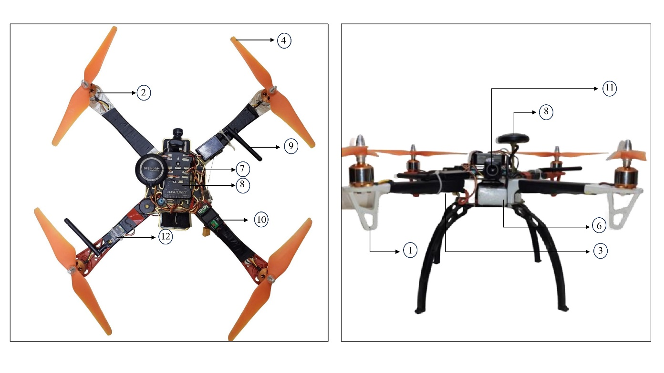

Figure 3.1 Left side figure is top view, Right side figure is Front view

## 3.2 Frame

The structural foundation of quadcopter drones is made up of quadcopter frames, with all the parts, including batteries, flight controllers, motors, propellers, and other electronics. Quadcopter frame designs can differ greatly depending on size, weight, durability requirements, and intended usage. These are a few typical designs for quadcopter frames..

The F450 frame is a popular choice among drones for building quadcopters

**Design**: The F450 frame has a sturdy design with four arms positioned in a "X" pattern around a central body plate. This configuration is appropriate for a variety of aerial operations since it offers stability and agility while in flight.

**Material**: Usually, premium materials that balance strength and weight, like carbon fiber or glass Fiber, are used to make the frame. This guarantees robustness while minimizing the quadcopter's total weight.

**Size**: The F450 frame is designed to accommodate 10-inch propellers with a diagonal motor-to-motor distance chassis. The size is ideal for medium-sized quadcopters since it provides a decent mix of mobility and stability.

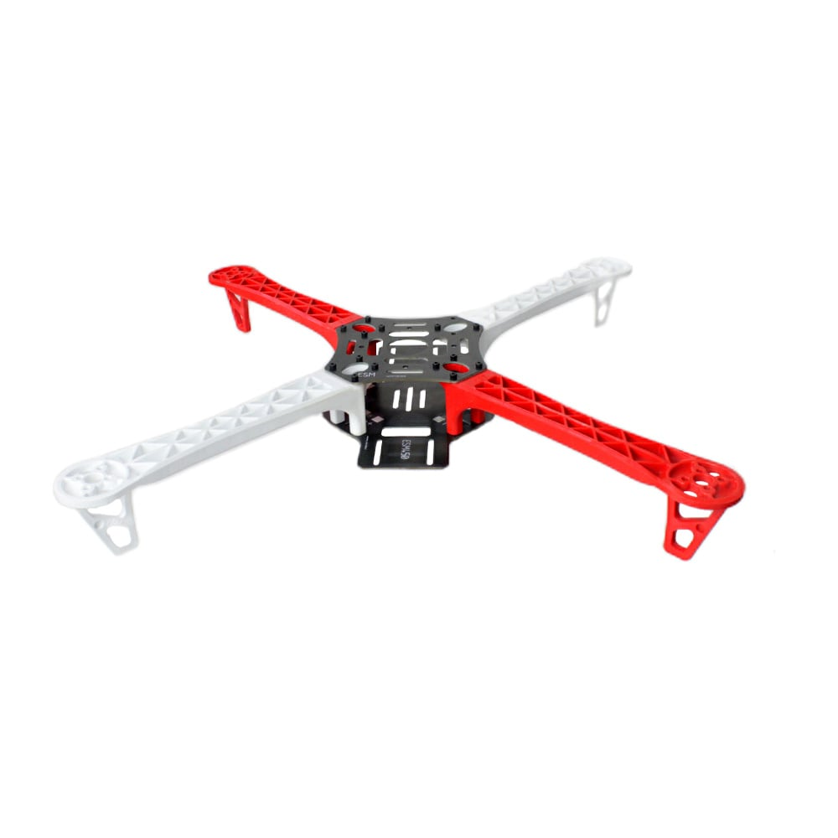

Figure 3.2 F450 frame

## 3.3 Motor

Drones and other small to medium-sized multirotor aircraft frequently use A2212 BLDC (brushless DC) motors. They are well-liked by hobbyists due to their effectiveness, dependability, and affordability.

The A2212 1000kV motor is selected for its various applications, including aerial photography, FPV racing, and recreational flying.

The specifications of motor are listed below:

Table 3.2 specification of BLDC motor

|  |  |  |
| --- | --- | --- |
| **S.NO** | **PARAMETERS** | **SPECIFICATION** |
| 1 | Model | A2212 13T |
| 2 | KV rating | 1000 KV |
| 3 | Supported battery type | 2S-4S li-po |
| 4 | Voltage range | 7.4v – 14.8v |
| 5 | Stator diameter | 3.17mm |
| 6 | Stator height | 12mm |
| 7 | Weight | 50-60g |
| 8 | Max continuous current | 10-13A |
| 9 | Max continuous Power | 120-150W |
| 10 | Max efficiency current | 4-10A |
| 11 | Max efficiency | 80% |
| 12 | Internal resistance | 0.5 – 0.6 ohms |
| 13 | Turns per stator arm | 13T` |

A number of variables, such as the surrounding environment, temperature, altitude, and motor specifications, are taken into account while testing thrust for certain motor and propeller combinations. But I can give you some thrust estimates for the A2212 1000kV motor at 11.1V (3S LiPo battery) with several propeller types:

Table 3.3 Propeller size and generated Thrust

|  |  |  |
| --- | --- | --- |
| **Propeller size** | **Voltage** | **Thrust in grams** |
| 8045 Propeller | 11.1v | 600-700g |
| 9050 Propeller | 11.1v | 700-800g |
| 1045 Propeller | 11.1v | 800-900g |
| 1145 Propeller | 11.1v | 900-1000g |

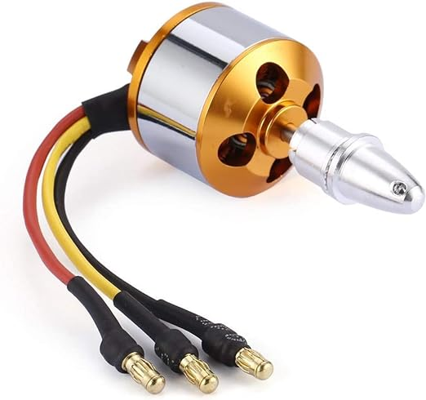

Figure 3.3 BLDC A2212 motor

## 3.4 Electronic Speed Controller (ESC)

An essential part of drone and RC (Remote Control) aircraft systems is an Electronic Speed Controller (ESC). Its main job is to change the voltage and current that electric motors get in order to control their speed and direction.

**Current Rating:** The "30A” in "Simonk 30A" typically denotes the maximum continuous current rating the ESC can handle. This rating indicates the maximum current that the ESC can safely supply to the motor without risking damage to the ESC or motor.

**Voltage Rating:** ESCs are designed to operate within a specific voltage range. Common voltage ratings include 2S (7.4V), 3S (11.1V), 4S (14.8V), and so on, corresponding to the number of cells in a lithium polymer (LiPo) battery.

**Protection Mechanisms:** ESCs frequently have a variety of safety features to guard against voltage spikes, overcurrent, and overheating. In the event of unfavourable circumstances or electrical malfunctions, these safeguards aid in preventing damage to the ESC and related components.

**Connectivity:** Input and output connectors for power, motor, and control signals are commonly found on ESCs. For motor connections, solder pads or bullet connectors are frequently used. For throttle control, servo-style connectors are commonly used.

Typically, a 30A ESC such as the Simonk 30A would weigh around 25 to 35 grams, including heat sinks and wiring.

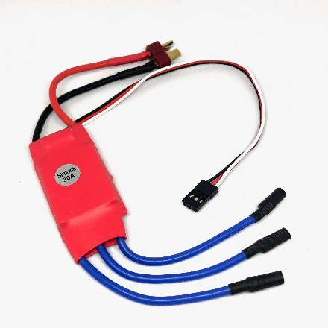

Figure 3.4 Simonk 30Amps

## 3.5 Propeller

We have chosen 1045 propeller for the our quadcopter due to the following:

* 800g of thrust at 11000rpm for 11.1v (3S LiPo battery).
* It gives the Thrust to Weight ratio of 2:1 which is important aspect for the UAV.
* The "1045" designation typically refers to the size of the propeller, specifically its length and pitch.
* "10" refers to the diameter of the propeller, measured in inches. So, in this case, it's 10 inches.

"4.5" denotes the propeller's pitch. Pitch is the amount of inches that, in the case of a soft solid, the propeller would advance in a single revolution. Thus, the pitch of this propeller is 4.5 inches.

These propellers are frequently found in quadcopters or drones of moderate size. They are appropriate for a range of airborne duties and manoeuvres because of their design, which strikes a balance between thrust, efficiency, and stability.

When selecting propellers for a drone, it's essential to consider factors such as weight, motor specifications, and Thrust to Weight ratio to ensure optimal flight performance and efficiency.

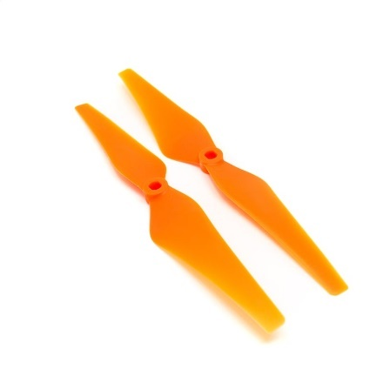

Figure 3.5 1045 propellers

## 3.6 Battery Elimination Circuit

A Battery Elimination Circuit (BEC) is a crucial component in drones. In a drone configuration, a BEC's main function is to control and maintain a steady voltage supply for the flight controller, receiver, and additional auxiliary electronics. The "Battery Elimination Circuit" refers to the fact that it does away with the requirement for separate batteries to power these components.

BECs are frequently included into electronic speed controls (ESCs). The speed of the motors is managed by ESCs, and many of them have a built-in BEC to supply power to the flight controller and other onboard electronics.

BECs typically step downs the higher voltage from the main drone battery which could be a LiPo battery to 5-7v for the flight controller.

BECs deliver pure, steady power with low noise and voltage ripple. Noise or spikes in voltage may interfere with the functioning of delicate electronics, reducing the drone's performance and stability.

When incorporating BECs into a drone configuration, safety must be taken into account. A BEC may overheat and malfunction if its rated capacity is exceeded.

For safe and steady drone operation, it is imperative to choose a BEC with the right voltage rating, current capacity, and dependability.

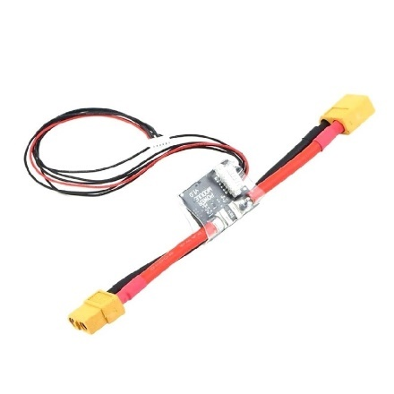

Figure 3.6 BEC module

## 3.7 Battery

A particular kind of battery that is frequently used to power drones and other remote-controlled devices is called a LiPo (Lithium Polymer) battery. Lithium polymer (LiPo) batteries are the most often utilized battery type in drones. Lithium-based cathode and anode separated by a polymer electrolyte make up LiPo batteries.

Compared to nickel cadmium or nickel metal hydride batteries, lithium-based batteries have a higher energy density, which allows them to hold more energy while weighing less. In terms of energy density, LiPo batteries are comparable to Li-Ion batteries, however they are more widely used due to their lower leakage rate.

Here we are using 11.1v, 3s (3 cell), 35C, 4200maH LiPo battery

**Voltage:** The battery's nominal voltage and number of cells are indicated by the "3S" designation. Three separate cells make up a 3S LiPo battery, which normally has a nominal voltage of about 3.7 volts (4.2 volts when fully charged). As a result, the nominal voltage of a 3S LiPo battery is around 11.1 volts (12.6 volts when fully charged).

**Battery Capacity**: You may estimate your flying time using the battery capacity, which is expressed in mAh or Ah (more on this later). The amount of hours that a battery can supply current or power is a more precise definition of battery capacity. Typical measurements are in ampere-hours (Ah).

**Battery Voltage Rating:** The battery's voltage rating will let you know what your motor speed and amperage are. Your motor's speed will depend on how many volts your battery can provide, as motors are rated in Kv with the unit RPM/Volt.

**Discharge/ C Rating**: The pace at which the battery can safely discharge is known as the discharge rate, or the C rating. You could safely drain a battery that has a C rating of 35 and a capacity of 4200 mAh/4.2 Ah at 35 times the battery's capacity, or 35 x 4.2 = 147 Ah. The 4.2 Ah battery may run out of power in 1.7 minutes if electricity was used continuously at that rate (4.2 / 147) x 60 = 1.7).

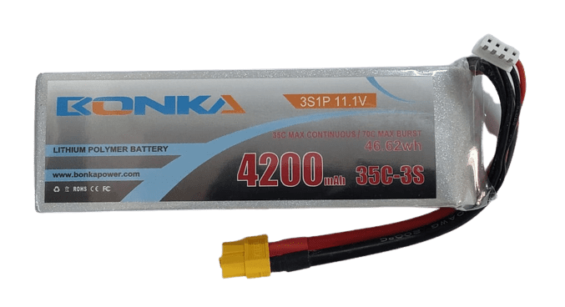

Figure 3.7 LiPo Battery

## 3.8 GPS (Global Positioning System)

U-Blox GPS modules are widely used in drone applications due to their high accuracy, reliability, and advanced features tailored for UAV (Unmanned Aerial Vehicle) operations.

GPS modules provide extremely accurate positioning, giving exact location information that is essential for waypoint tracking and drone navigation. Even in difficult circumstances, they increase satellite availability and accuracy by utilizing multi-constellation support (GPS, GLONASS).

GPS modules are designed to use little power, which saves energy and prolongs flying duration for drones that run on batteries. They use cutting-edge power management algorithms and power-saving technologies to reduce energy consumption without compromising functionality.

The model and configuration options of a GPS module might affect the data transmission rate. The data transmission speeds that GPS modules typically enable range from 9600 bits per second (bps) to 115200 bps.

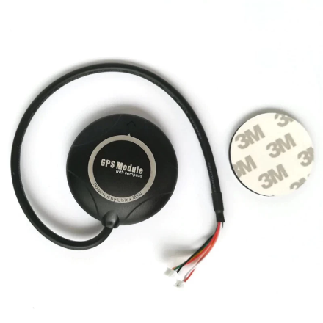

Figure 3.8 U-Blox GPS module

## 3.9 Flight controller

Pixhawk Flight Controller (Pixhawk 2.4.8)

The drone's (quadcopter's) brain is the flight controller. Pixhawk 2.4.8 is equipped with a circuit board that has a variety of sensors that can detect both user commands and drone movement. It then uses this information to regulate the motors' speed so that the craft moves in the desired direction.

It has 8 main ports & 6 auxiliary ports. There are numerous user interfaces available for programming, examining logs, and even using certain programs on tablets & smartphones. It automatically recognizes and sets up every peripheral.

The Pixhawk 2.4.8 is a well-liked and adaptable flight controller. It is regarded as one of the greatest flight controllers in its class for the following reasons:

**ArduPilot Firmware**: The open-source ArduPilot autopilot firmware is supported by Pixhawk 2.4.8. This implies that it gains from a sizable user and development community that consistently works to enhance it.

**Multi-Rotor Support**: Pixhawk 2.4.8 can be used with a variety of multi-rotor platforms, including octocopters and quadcopters.

**Fail-Safe Modes**: Several fail-safe modes are supported by Pixhawk 2.4.8, ensuring that in the event of a signal outage or other emergency, the drone can land or return home safely.

**GPS Support**: It may handle multiple GPS modules, which makes navigation and exact positioning possible.

**Telemetry and Communication**: Pixhawk 2.4.8 is compatible with telemetry systems, enabling real-time monitoring and control connection between the drone and base station.

|  |  |
| --- | --- |
| STATUS | Pattern |
| ARMING | 3 sec long Beep |
| ARMING FAILURE | Single Beep |
| DISARMED | Single Beep |
| BATTERY FAILSAFE | Single Beep repeating every 3 sec |
| EKF FAILURE | Beeeep-Beeep-Beep-Beep |
| LOST VEHICLE | Beep-Beep repeating every 3 sec |
| GYRO INIT DONE | 7 short beeps |
| READY TO ARM | Beep-Beep-Beep-Beeeeeep |

Pixhawk beep pattern for various messages

Table 3.4 Pixhawk beep pattern and messages

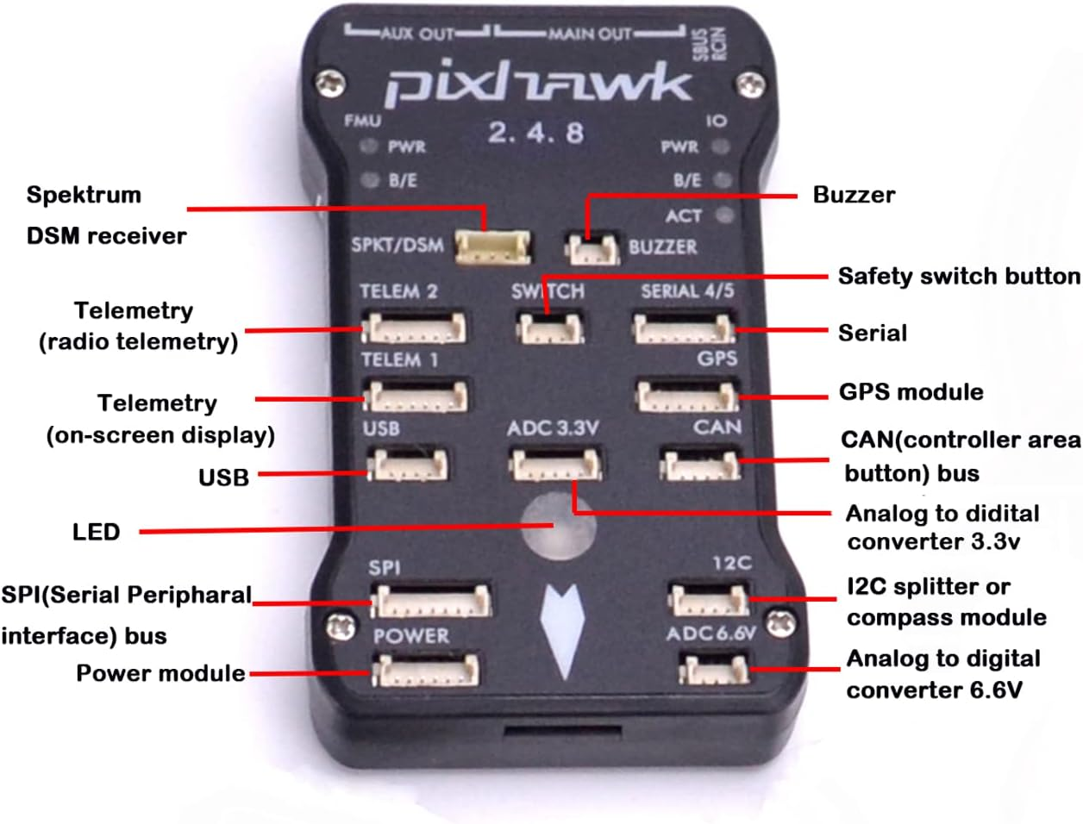

Figure 3.9 Pixhawk Flight Controller

## 3.10 Telemetry module

An essential part of unmanned systems, the Pixhawk telemetry module allows wireless communication between the vehicle and the ground control station, improving situational awareness, operational capabilities, and mission performance.

In unmanned aerial vehicles (UAVs) and other autonomous systems that make use of the Pixhawk flight controller, the Pixhawk telemetry module is an essential part. Telemetry modules enable operators to monitor and control the vehicle remotely by facilitating real-time communication between the vehicle and a ground control station (GCS). The following is a summary of the features of the Pixhawk telemetry module:

**Telemetry Communication Protocol**: Radio frequency (RF) communication is commonly used by the Pixhawk telemetry module to create a two-way data link between the UAV and the ground control station. This makes it possible to transmit telemetry data, which includes flight parameters, GPS data, sensor readings, battery status, and other data.

**Compatibility**: The Pixhawk flight controller, which is extensively utilized in a variety of UAV platforms, including multi-rotors, fixed-wing aircraft, helicopters, and even ground vehicles, is compatible with the Pixhawk telemetry module. It offers dependable telemetry capabilities by integrating with the Pixhawk ecosystem in an effortless manner.

**Range and Reliability**: The operating range of the telemetry module is 800-1000 meters, contingent upon the particular radio frequency and transmission power employed. While lower frequencies offer greater ranges but may be more prone to interference, higher frequencies generally offer shorter ranges but may offer better penetration through barriers. Furthermore, error correction and frequency hopping are two further capabilities that telemetry modules frequently include to guarantee dependable connection even in difficult settings.

**Data Transmission Rate**: High-speed data transmission is supported by the telemetry module, enabling real-time monitoring of crucial flight characteristics and telemetry data. This allows operators to decide on the best course of action and modify flying characteristics as necessary while on the mission.

**Security**: Certain telemetry devices provide encryption and authentication features to protect data and stop unwanted access. By doing this, confidential telemetry data is safeguarded and possible security lapses or outside intervention are avoided.

**Integration with Ground Control Software**: The telemetry module easily interfaces with ground control programs like Mission Planner or Q Ground Control, giving users a user-friendly interface via which they can plan missions, set waypoints, monitor telemetry data, and remotely operate the vehicle. This makes it possible to plan and carry out missions effectively and to maintain situational awareness in real time while conducting flying operations.

Two-way telemetry connection between your drone and ground station with frequency of 915MHZ and range of 1-1.5km which uses MavLink Framework for the communication.

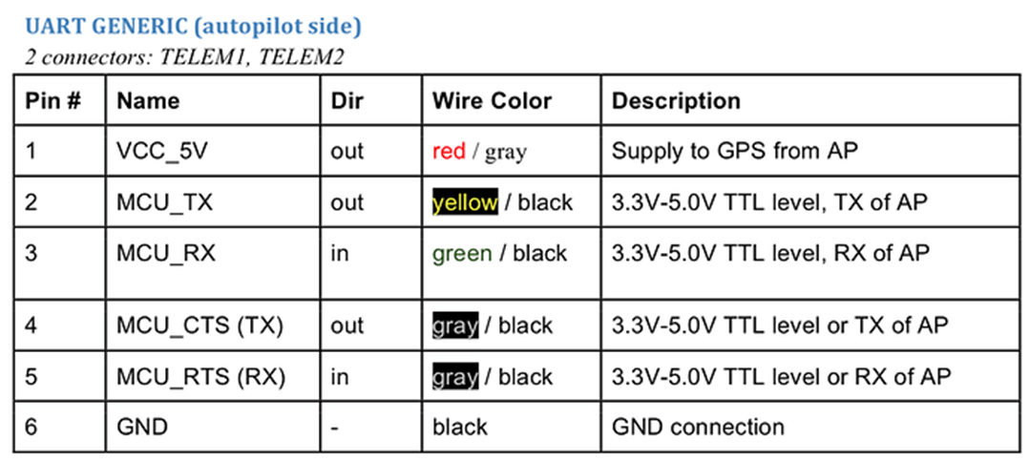

Figure 3.10 Telemetry module pin description

## 3.11 The Transmitter and Receiver

Drone operation requires a transmitter and receiver system because it gives pilots exact control and enables smooth communication between the drone and controller. Typically, a quadcopter has a 6-channel receiver that allows the drone to be controlled in terms of pitch, roll, yaw, and throttle. The majority of controllers operate on the 2.4 GHz communications frequency. Even while interference is unlikely, it might be something to look at if your quadcopter is experiencing latency, or the lag or dropouts in communications.

Additionally, the controller features 4 trim buttons that let you adjust your quadcopter transmitter joysticks slightly for optimal flying performance. Applying trim for that control input in the opposite direction will stop the drone from drifting if you observe that it does so when there is no control input.

### 3.11.1 Uses of Transmitter:

**Remote Control:** The transmitter's main job is to control the drone's actions from a distance, including turning, descending, and changing its speed.

**Flight Commands:** It enables the drone to respond to directions from the pilot, including take-off, landing, and switching between flying modes.

**Control Configuration:** Various control configurations or modes are available on the transmitter to accommodate the pilot's flying style and preferences.

**Emergency Response:** The transmitter lets the pilot respond swiftly and take remedial action in the event of an emergency or unanticipated circumstance to avoid collisions or accidents.

### 3.11.2 Uses of Receiver:

**Signal Reception:** The signals that the pilot transmits through the transmitter are picked up by the receiver, which then transmits them to the drone's flight controller.

**Wireless Communication:** It creates a wireless communication channel that enables feedback and control in real time between the drone and the transmitter.

**Binding Process:** A secure connection is established between the transmitter and receiver through a binding process that makes sure that only authorized signals are acknowledged.

**Signal Processing:** The drone's flight controller receives signals from the transmitter, which are processed by the receiver, which then decodes and converts them into useful orders.

We have opted for the Fly sky i6 transmitter and receiver system to operate our drone.

### 3.11.3 Fly sky i6 Transmitter:

Features:

* Easy to use, straightforward design for extended flights.
* LCD monitor for telemetry data real-time and setting modification.
* customizable channels that can be programmed based on user preferences.

**Modes of Operation of transmitter:**

1. Transmitter Mode 1 is the European standard:

Throttle channel 3 on the vertical axis of the right stick, and Elevator channel 2 on the vertical axis of the left stick.

1. Transmitter Mode 2 is the U.S. standard which has the vertical sticks reversed:

Throttle channel 3 on the left stick and Elevator channel 2 on the right stick. The FS-i6 transmitter comes with Mode 2 enabled.

Supports multiple modes for different UAV control configurations.

1. Loiter mode
2. RTL mode (Return To Launch)
3. Land
4. Position hold mode
5. Altitude hold mode
6. Stabilize mode

Table 3.5 flight modes and its control switches

|  |  |  |
| --- | --- | --- |
| **UAV** **FLIGHT MODES AND ITS CONTROL SWITCHES** | | |
| **SWITCH 1** | **SWITCH 2** | **FLIGHT MODE** |
| SwB 1 | SwC 1 | LOITER MODE |
| SwB 1 | SwC 2 | RTL |
| SwB 1 | SwC 3 | LAND MODE |
| SwB 2 | SwC 1 | POSITION HOLD |
| SwB 2 | SwC 2 | ALTITUDE HOLD |
| SwB 2 | SwC 3 | STABILIZE |

### 3.11.4 UAV Controls for movements:

Various controls and buttons for THROTTLE, PITCH, ROLL, YAW, and auxiliary functions.

**Pitch Control:** Another name for it is elevator operation. Using the right-side stick, we may adjust the pitch in Channel 2 for the transmitter mode 2.

**Roll Control:** Another name for it is aileron operation. We can use the right-side stick to control roll in Channel 1 for the transmitter mode 2.

**Yaw Control:** Another name for it is rudder operation. We can use the left-side stick in Channel 4 to adjust yaw for the transmitter mode 2.

**Throttle Control:** We may adjust the throttle for the transmitter mode 2 by using the left side stick on channel 3.

### 3.11.5 Flysky i6 Receiver:

Features:

• Reliable communication through seamless connection with the Flysky i6 transmitter.  
 • Compact and lightweight design for effortless insertion into drones.

**Range and Signal Strength:**

Provides steady drone control with a robust signal strength and dependable range. The frequency range of the FlySky Fs i6 is 2.475 GHz. For realistic outdoor scenarios, the radio technology ensures a jam-free long-range radio transmission of 1000 meters and 800 meters.

**Number of Channels:**

FlySky FS i6 receiver offers 6 channels control

**Applications and Uses:**

The Flysky i6 system finds applications in various drone-related activities such as aerial photography, videography, racing, and FPV (First Person View) flying.

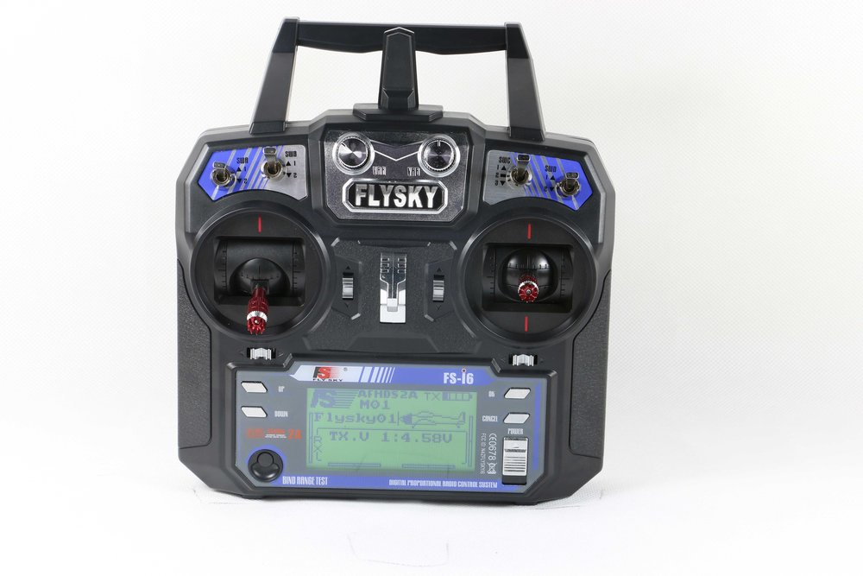

Figure 3.11 Flysky i6 Transmitter



Figure 3.12 Flysky i6 Reciver

## 3.12 Camera

The High Definition 1200TVL CMOS Camera with 2.1mm Lens FPV Camera is specifically made for RC drones and multi-copters, and it offers exceptional imaging performance. This camera's 1200TVL resolution allows it to capture remarkably clear, detailed footage—an essential feature for immersive first-person virtual reality experiences. Pilot situational awareness is enhanced by the 2.1mm wide-angle lens's large field of vision and fast image recording periods, which are made possible by the CMOS image sensor technology. Because of its lightweight design, the drone maintains its optimal flying performance by lowering its overall weight and aerodynamic effect. This camera is compatible with a range of flight controllers and video transmitter systems, and it offers versatility and ease of integration with mounting brackets for straightforward installation and adjustment.

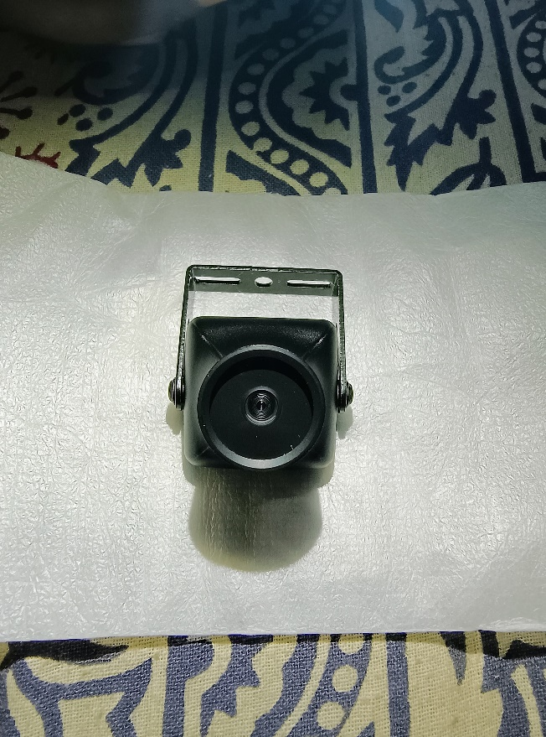

Figure 3.13 FPV camera 1200TVL

## Video transmitter

The TS5823 200mW 40CH Mini Transmitter is designed for first-person perspective (FPV) applications and is robust and compact. With an output power of 200mW and 40 channels to choose from, it offers flexibility for live video streaming. Its compact size makes it simple to incorporate into a range of configurations, such as FPV drones, RC cars, planes, and other remote-controlled vehicles.

The transmitter is compatible with many frequency bands to ensure compatibility with a wide range of receivers and to prevent interference. Users can select the channel that best suits their needs and environment; some devices feature easy-to-use buttons or LED signals. Installation is easy because it has mounting holes or an adhesive backing for a snug fit.

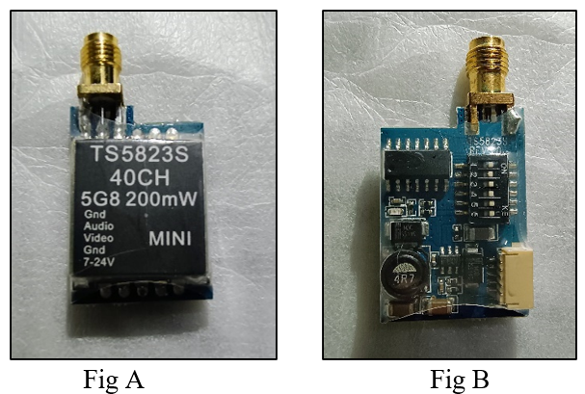

Figure 3.14 Video transmitter TS5823S

Figure 3.14 (A) shows the front view of the transmitter while the figure B is the rear view of the transmitter. Frequency range and channel line can selected with the toggle switch on the rear part of the transmitter.

## 3.14 Video receiver

The 5.8GHz FPV Receiver is a compact and practical gadget designed to stream live movies from Android tablets or smartphones. It uses UVC technology to operate on the 5.8GHz frequency spectrum, and it easily connects to Android devices that are suitable and enable USB OTG. With FPV drones or other compatible sources, users may easily acquire live video feeds directly onto their Android devices, providing quick visual feedback. Its plug-and-play setup, which does not require additional software installations or drivers, makes it easy to operate.

For FPV applications that need quick control and lifelike flying experiences, the receiver's low-latency transmission function is crucial. Its compact design and portability make it ideal for usage on the go, and its integrated antenna or SMA connector provide the best possible signal quality. Because the Android device's USB connection powers it, no extra power sources are needed. To ensure a smooth integration, users can refer to the provided user manual for detailed setup instructions and specifications. The product is called 5.8G UVC OTG Android AV Phone Receiver.

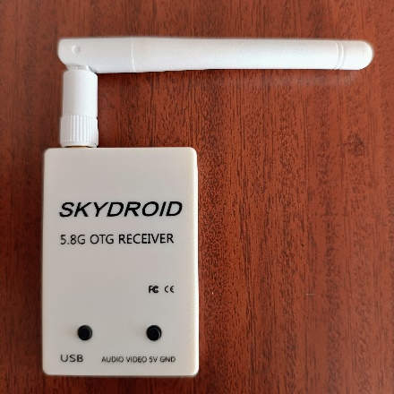

Figure 3.15 Sky Droid 5.8GHz reviver

## 3.15 Shock absorber

In drone or UAV (Unmanned Aerial Vehicle) design, the term "Pixhawk shock absorber" usually refers to the use of a Pixhawk flight controller with a shock-absorbing mechanism.

Certain drone designs employ shock absorbers to mitigate the effects of vibrations and sudden movements on the flight controller and other fragile components, particularly in harsher or more demanding environments. These shock absorbers come in a range of forms, including rubber mounts, springs, and other damping elements.

Shock absorbers are combined with a Pixhawk or any other flight controller to limit vibrations and shocks that may emerge during flight, notably during take-off, landing, and in turbulent situations. This improves stability, prolongs the life of the vehicle, and improves performance.

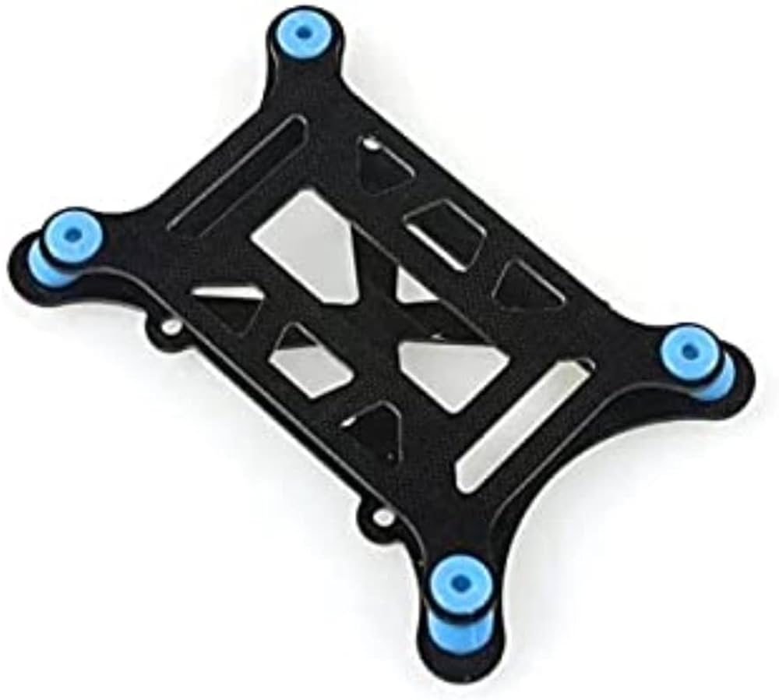

Figure 3.16 Shock Absorber

# System Design and Calibrations

## 4.1 Quad-copter Introduction

A quad-copter, sometimes referred to as a quad-rotor or multi-rotor drone, is a marvel of contemporary engineering that is distinguished by its straightforward but efficient design. This flying mechanical vehicle, which consists of four arms with motors attached to propellers in each, works on the basic principles of aerodynamics. Although there are variants with three, six, or eight rotor configurations, they all function according to the same principle as the quadcopter.

The quadcopter's layout produces a balanced lift and allows for steady flying by having two rotors that revolve clockwise and the other two that rotate counterclockwise. But even with their deceptively simple design, quadcopters are aerodynamically unstable by nature. They use advanced flight computers to combat this instability and guarantee safe flight.

These flight computers are essential for translating pilot directions into changes in the propellers' revolutions per minute (RPMs), which allows for exact control over the drone's movements. In contrast to conventional aircraft, which mostly rely on their wings to produce lift, quadcopters obtain lift from the thrust generated by their propellers.

Helicopters and fixed-wing aircraft use different mechanics for lift and control, which is how quad-copters differ from them fundamentally. Quad-copters only use variations in propeller RPMs for both lift and control forces, whereas helicopters use their main rotors to generate lift and have the ability to adjust the pitch of their rotor blades for control.

Although the idea of a quadcopter is not new, the early manned models from the 1920s and 1930s suffered from unstable flight characteristics, poor performance, and difficult piloting requirements. Nonetheless, the field of aerial robots has seen significant change due to the quick development of electrical technology. Highly competent and effective quadcopters have been made possible by advancements in flight control computers, brushless motors, microprocessors, batteries, accelerometers, cameras, and GPS systems.

Modern technology combined with the straightforward design of the quadcopter has given it a very flexible platform. Beyond their recreational uses, quad-copters are widely used in aerial photography and cinematography because they offer unmatched perspectives and capabilities for taking breathtaking pictures from the air.

### 4.1.1 Quad-copter Hovering

When the upward lift equals the downward pull of gravity, hovering occurs. The lift force must be larger than the gravitational force in order to propel the drone upward. This is accomplished by concurrently raising the RPM on all four propellers, which increases lift. Simultaneously reducing the RPM on all four propellers lowers the altitude. This is done on your controller by pushing the left stick up or down, which raises or lowers the rotor RPM and causes your quadcopter to rise or fall.

We adjust the lifting force's angle such that it has a vertical and horizontal component in order to move the drone left, right, forward, and backward. While the horizontal component allows for the production of control thrust, the vertical component continues to keep the quadcopter in the air.

### 4.1.2 Quad-copter Motion

The right stick on the controller is used to change the pitch, which causes the quadcopter to travel forward or backward. The result is a decrease in RPMs for the front propellers and an increase for the rear propellers. The lift force now includes a horizontal component, which causes the quadcopter to advance. If the opposite occurs, your quadcopter will reverse itself. There is a drop in the rear propeller RPM and an increase in the front propeller RPM.

An analogous shift in RPM occurs to move your quadcopter sideways; however, it occurs on the left and right propeller this time. You must gently angle the lift force to the left in order to get your drone to go to the left. The left rotors' RPM is lowered, and the right rotor's RPM is raised, to achieve this. To shift your quadcopter to the left, make a comparable adjustment to the rotor revolution rates.

### 4.1.3 Yaw Movement

Yaw is more difficult to picture. Have you ever wondered why a helicopter has a tail rotor? Its purpose is to prevent the helicopter's body from whirling. Due to torque reaction, the fuselage will begin turning clockwise if the main blades are rotating counterclockwise, as they are in the majority of helicopters. The Third Law of Dynamics by Newton has this effect. In order to keep the helicopter fuselage from rotating, the tail rotor balances off the torque reaction on it.

The body of a quadcopter would rotate in the opposite direction if all four propellers rotated in the same direction. However, it clearly doesn't. This is a result of the propellers rotating counter-clockwise for two of them and clockwise for the other two. Thus, a torque is produced in one direction by one set of propellers, while a torque is produced in the opposite direction by the other two propeller sets. The quadcopter does not rotate as a result of these cancelling out.

We do want the quadcopter to rotate in order to perform a yaw manoeuvre. To achieve this, one set of rotors' RPM is decreased, while the RPM of the other set of rotors is increased. Your quadcopter now rotates since there is a net torque in one direction. Just reverse the propellers' RPMs to create the opposite rotation. The left stick on the controller determines the direction of the yaw manoeuvre.

## 4.2 Wiring Schematics

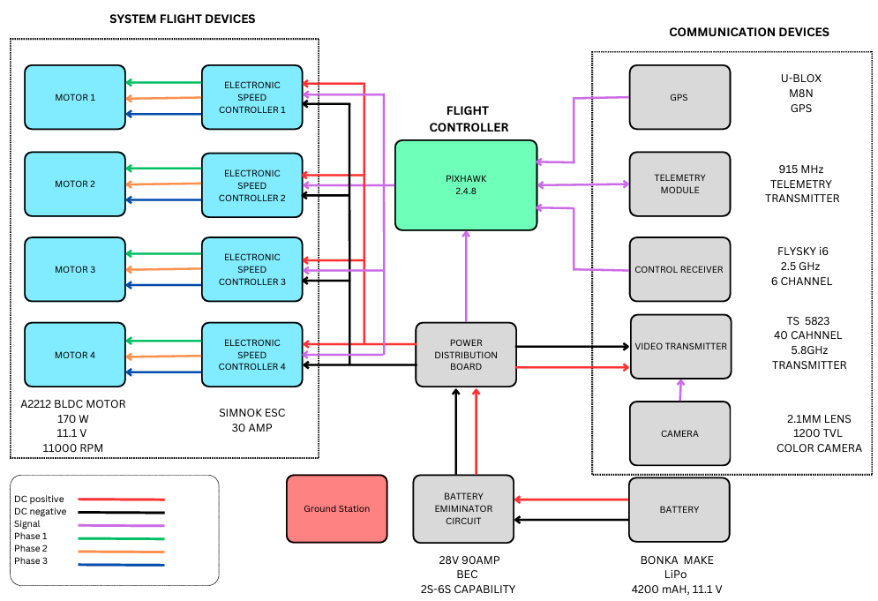

Figure 4.1 Block Diagram of the wiring of the Quadcopter

The above Figure 4.1 is the block diagram of the drone designed, it consists of the major 3 sections

1. System flight devices
2. Flight controller
3. Communication devices

The flight devices of the system are the motors and speed controllers. The 3 wires of the motors are connected to the esc controller 3 phase out, and the DC power is supplied by the battery connected to BEC. In contrast, the signal wire transmits the PWM signal and is attached to the flight controller's serial main out. The flight controller connects the communication devices to their assigned ports; still, precise pin marking is required to guarantee that the devices are communicating with each other.

## 4.3 Assembly of UAV

The BEC (Battery Eliminator Circuit) and the power distribution board (PDB), where the BEC is connected to the flight controller, are coupled to the LiPo battery with 11.1v and 4200maH 3s via xt60 male and female connectors (PIXHAWK 2.4.8). The Electronic Speed Controller (ESC) power input is soldered to the power distribution board, and the BLDC motors are linked to the ESC's three-phase output. We currently have the system flight devices attached.

The Pixhawk Flight Controller has communication ports, and the GPS module, telemetry module, and controller receiver are now linked to it at a voltage of +5v or +3.3v. The pins are locked together to ensure a secure connection. The video transmitter's power supply is supported by the power distribution board's parallel connection, and the camera is powered by the flight controller's auxiliary supply by connecting to the AUX 1 pin port.

Depending on how the drone motor is configured, the flight controller's main port is connected to the ESC signal pins and the micro controller's power supply.

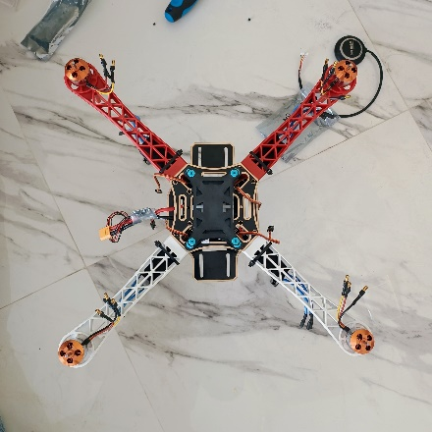 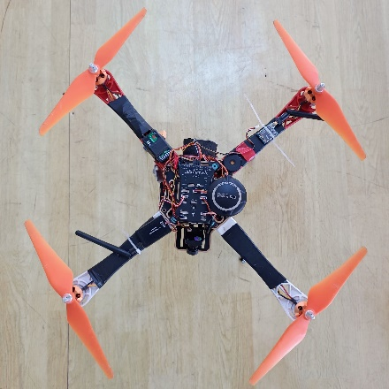

Figure 4.2 Pictures of the UAV before and After assembly

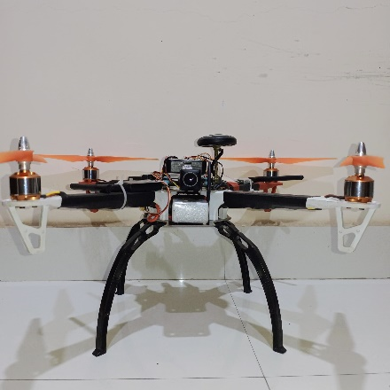

Figure 4.3 Front view of Final assembly

## 4.4 Quadcopter DOF and Transmitter control

A quadcopter's six degrees of freedom (DOF) regulate all aspects of its three-dimensional operation, including rotation and translation. With the help of these DOF, translation can be adjusted by rotation about the longitudinal axis (roll), vertical axis (yaw), lateral axis (pitch), and forward/backward (pitch), left/right (roll), and up/down (throttle) axes. The quadcopter can perform a wide range of flight manoeuvres with agility because to its wide range of motion.

The transmitter serves as the primary interface for controlling the quadcopter's movement in conjunction with an onboard receiver. To wirelessly transfer commands to the quadcopter, pilots manipulate the transmitter's controls. Pilots can intuitively adjust the quadcopter's throttle, pitch, roll, and yaw to have precise control over its flight.

.

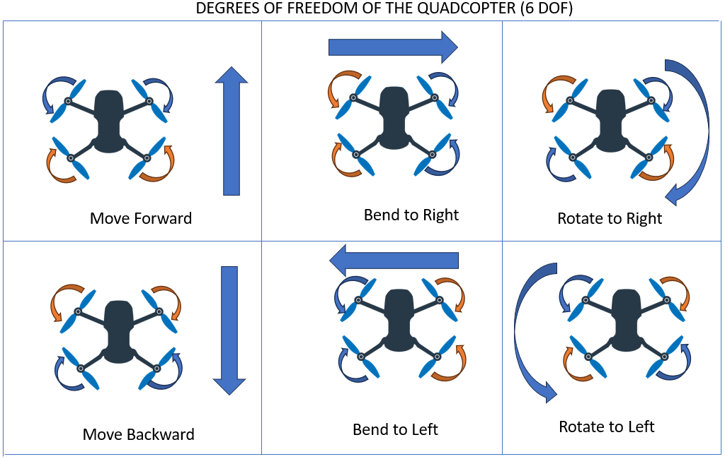

Figure 4.4 The 6 DOF of a Quadcopter

## 4.5 Mission Planner Software

For new users, we suggest that you use Mission Planner. The following steps are shown below:

### 4.5.1 Install Mission Planner

1. You have to install the mission planner and driver from the link below.

Download the latest Mission Planner from here:

<http://www.radiolink.com.cn/firmware/MissionPlanner/MissionPlanner-latest.msi>

Download the driver form here:

<https://www.microsoft.com/net/download/dotnet-framework-runtime/net462>

Open the Microsoft installer file and select Run to run the installation utility.



Figure 4.5 APM planner setup window screen shot

### 4.5.2 Mission Planner Introduction

Click the system icon to launch Mission Planner after installation is finished.

When you launch Mission Planner for the first time after installing the driver and Mission Planner, a number of pop-ups will appear. For the first pop-up clicks Yes and the others click NO.

There are six Menu Button in main menu.

**FLIGHTDATA:** flight attitude and data will show in real time on MP

**FLIGHTPLAN:** planning the flight mission

**INTIAL SETUP:** for firmware installation and update, Mandatory Hardware and Optional Hardware setup

**CONFIG/TUNING:** including detailed PID setup and parameters change

**SIMULATION:** make PIXHAWK work as a simulator after upgrade a special simulation firmware

**HELP:** you can get help when you have questions about MP

### 4.5.3 Initial Setup

When you are ready to utilize PIXHAWK for the first time, you must first upgrade the firmware. When using quadcopter firmware, the radio link PIXHAWK is the default; if you use another frame drone, you must install the appropriate firmware.

**Download and Install Firmware**

Please use a USB cable to connect your PC and PIXHAWK. Select the appropriate COM port from the drop-down menu in the upper-right corner of the screen while the Mission Planner is open (near the Connect button). Verify that the displayed Baud rate is 9600.

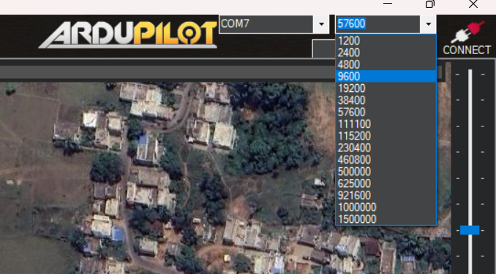

Figure 4.6 Baud rate and Port selection window

To install the firmware, click "Yes."

After disconnecting the USB cord, click OK, and then plug it back in right away (be aware that if there are several COM ports, PIXHAWK won't connect; please unplug any additional devices).   
If there is a red status LED, the PIXHAWK is updating its firmware.

Motors will operate at idle speed after disarming, according to a pop-up warning that appears after updating firmware to version 3.1.

In order to link your PIXHAWK and computer when the firmware has been installed, please click "CONNECT." When it turns green, a successful connection is made.

## Calibrations and Tuning

There are three types of calibrations that need to be completed in order for a motor to be tuned correctly.

The 3 calibrations are: Accelerometer calibration, Compass Calibration, Radio Calibration.

The technique of Accelerometer calibration in Pixhawk setup ensures precise acceleration measurement in all dimensions by arranging the drone in multiple orientations. Compass calibration gives accurate heading information and lessens magnetic interference by calibrating the internal magnetometer. Radio calibration is required to guarantee precise control inputs and a seamless connection between the transmitter and Pixhawk. These calibrations are necessary to increase flight performance and stability. They guarantee a drone that runs reliably and safely by helping to minimize errors and flaws. Every calibration operation involves specific procedures that must be followed in order to configure the Pixhawk system accurately.

Appropriate calibration increases the overall flying experience by ensuring optimal sensor readings and smooth flight control.

### 4.6.1 Accelerometer Calibration

This section demonstrates how to use Mission Planner to calibrate an accelerometer.

Ensure that the PIXHAWK remains horizontal during the accel calibration process. Radio calibration and Compass calibration



Figure 4.7 Accel Calibration window

1. Place vehicle level and press any key to save setting.
2. Place vehicle on its LEFT side and press any key to save setting.
3. Place vehicle on its RIGHT side and press any key to save setting.
4. Place vehicle DOWN and press any key to save setting.
5. Place vehicle UP and press any key to save setting.
6. Place vehicle on its BACK and press any key to save setting.

### 4.6.2 Compass Calibration

This section shows how to perform compass calibration using Mission Planner.

There are two situations about compass calibration:

1. Without GPS, use internal compass

2. With GPS, use external and internal compass.

When using a GPS, the calibrate interface will seem as the image below. It is not necessary to establish the GPS direction in MP if the GPS is positioned in the same direction as the flight controller; however, if the GPS is mounted in a different direction from PIXHAWK, then MP setup is required.

Please fix PIXHAWK and TS100. Then, click "Start" and continue to turn PIXHAWK and TS100 until the Mag 1 and 2 progress bars reach the finish and the indicated words MAG_CAL_SUCCESS appear.

**Calibrate the compass as these steps below:**

1. While the vehicle is still in the air, carefully spin it such that the front, rear, left, right, top, and bottom all point downward toward the earth for a brief period of time.
2. When you calibrate the compass, the mission planner will continue to record the data that is gathered by the compass sensor and the progress bar. If the % has not changed, please verify that the compass is successfully connected.
3. You will receive a reminder from the mission planner once the compass has calibrated success.
4. After restarting the PIXHAWK, click OK and reconnect the device to the computer. The compass will successfully calibrate.



Figure 4.8 Compass Calibration window

### 4.6.3 Radio Calibration

This section explains how to use Mission Planner to accomplish radio control calibration.

The movement and orientation of vehicles are controlled using RC transmitters. Rover only has throttle and roll control; the Copter and Plane only have minor control over pitch, roll, and yaw. Every one of these control signals is assigned to a transmitter stick or switch, and then the linked receiver maps those stick or switches to the autopilot channels.

Moving each enabled stick or switch over its complete range and noting the maximum and minimum positions is all that is needed to calibrate each transmitter control or channel.

Transmitter mode in Mode 2

**Mode 1:** left stick controls pitch and yaw, the right stick will control throttle and roll.

**Mode 2:** left stick controls throttle and yaw; the right stick will control pitch and roll.

Copter default channel mappings are:

Channel 1: Roll

Channel 2: Pitch

Channel 3: Throttle

Channel 4: Yaw

Channel 5: Flight modes

**Radio Calibration Steps:**

1. Open Mission Planner

2. Choose the right COM and Baud rate

3. Click the CONNECT

4. Choose INITAIL SETUP—Mandatory Hardware—Radio Calibration and Click “Calibrate Radio”

5. Then click “OK” and move all RC sticks and switches to their extreme positions so the red bars hit the limits.

Now the Radio Calibration is done

(note: when calibrating the drone please remove the propellers to ensure safety)



Figure 4.9 Radio Calibration window

## Video Transmission and Receiving

Plugging in the power connector to the BEC activates the drone's transmitter. Upon activation, the video transmitter looks for a video signal and chooses the necessary radio frequency and channel.

Since the camera needs between 5 and 12 volts, power for it comes from the Pixhawk flight controller's aux.1 out (7V).

The 5.8GHz Sky droid recover is attached to the device for watching in order to receive the video feed from the transmitter.

The FPV VIEWER app needs to be downloaded in order to watch videos on Android mobile devices. The FPV viewer immediately detects the receiver when it is connected to the mobile device via a USB type-c cable. When it detects a stronger signal, it locks the stream frequency.

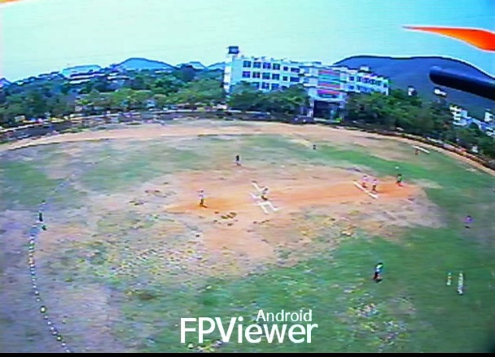 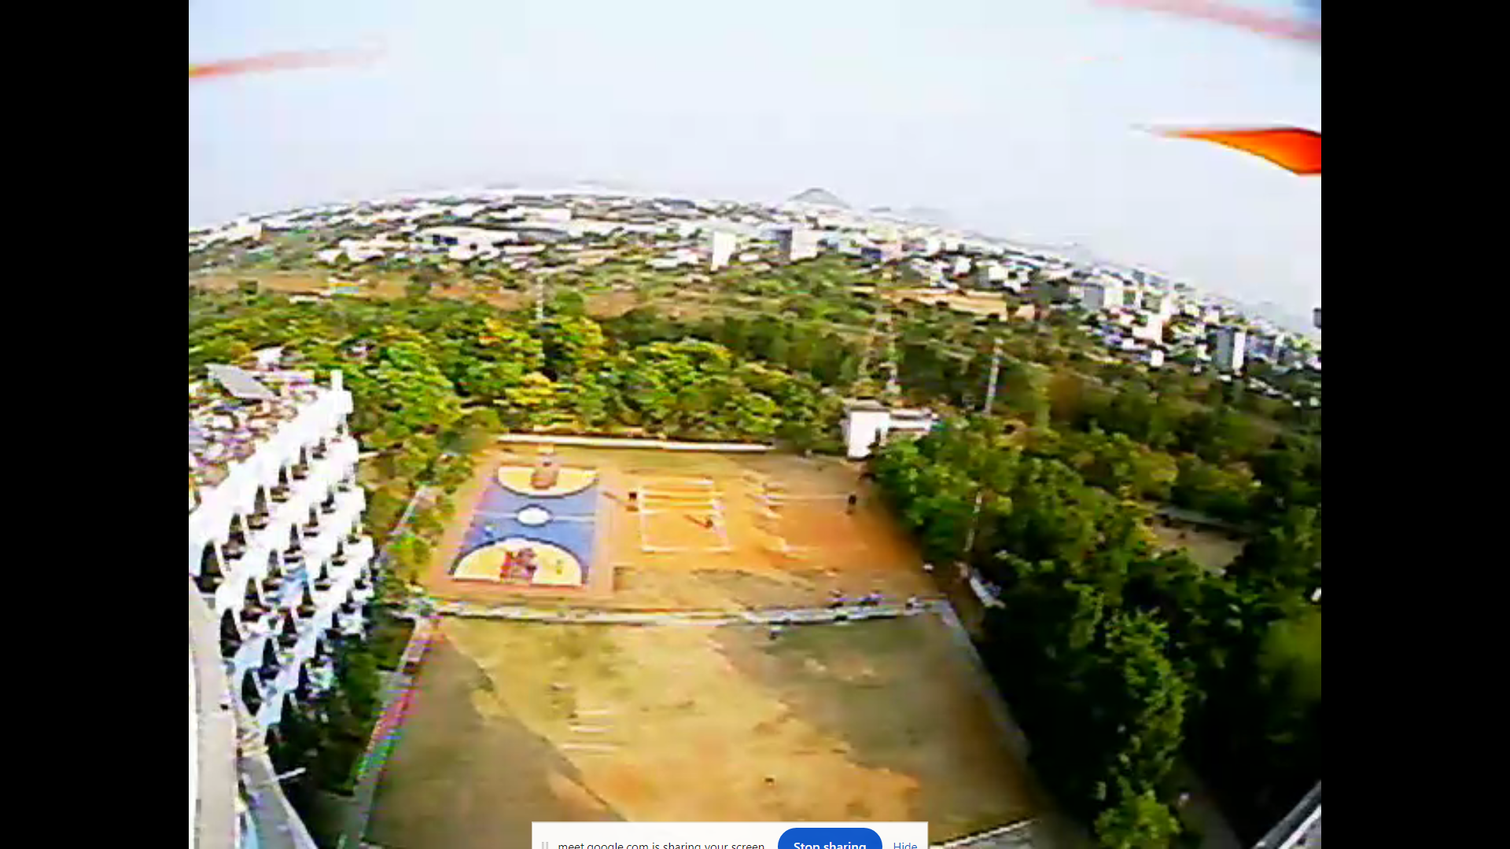

Figure 4.10 FP Viewer in android and Video stream in PC

One straightforward way to watch the video is to connect to a computer. The camera program should be accessed and the camera option switched as shown in figure 26 once the receiver and computer are linked via a USB cable. This will direct the camera to the receiver port that is attached.

By this way we connect and view the video in two ways as above discussed.

# Tests and Results

To check the drone compatibility in environment conditions and evaluate performance below tests were conducted.

The tests were performed at two different altitudes 10m & 20m.

## 5.1 Types of Tests

Four tests were taken into consideration. They are:

1. Altitude hold test
2. Stability test
3. Speed test
4. Payload test

### 5.1.1 Altitude hold test

The purpose of the altitude hold test is to evaluate the drone's stability while it is hovering at a constant altitude. The barometer sensor in the UAV's flight controller measures the surrounding pressure and converts it into altitude. As the UAV's altitude rises, the surrounding atmospheric pressure decreases. Parameters GPS.Alt and POS.Rel Alt are used to observe the original altitude and the measured altitude. The quadcopter is locked and left to hover at a specific altitude. After the test is performed flight controller is connected to PC using USB cable or telemetry module to download the data logs.

Altitude test is performed for two altitudes 10m and 20m. After the data logs are transformed into excel CSV files, graphs are plotted. The standard deviation is calculated in the excel sheet.

**Case 1: Altitude test at 10m**

From the test conducted the observed graph is show in , at constant wind speed 13Kmph, the observed altitude deviation between original and real altitude is 4.94m at an altitude of 10m and the error percentage deviation is 25.84.

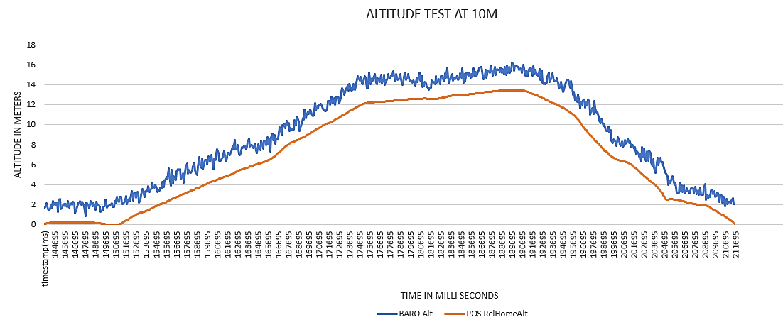

**Case 2: Altitude test at 20m**

From the test conducted the observed graph is show in Figure 5.2, at constant wind speed 13Kmph, the observed altitude deviation between original and real altitude is 9.5m at an altitude of 20m and the error percentage deviation is 41.41.

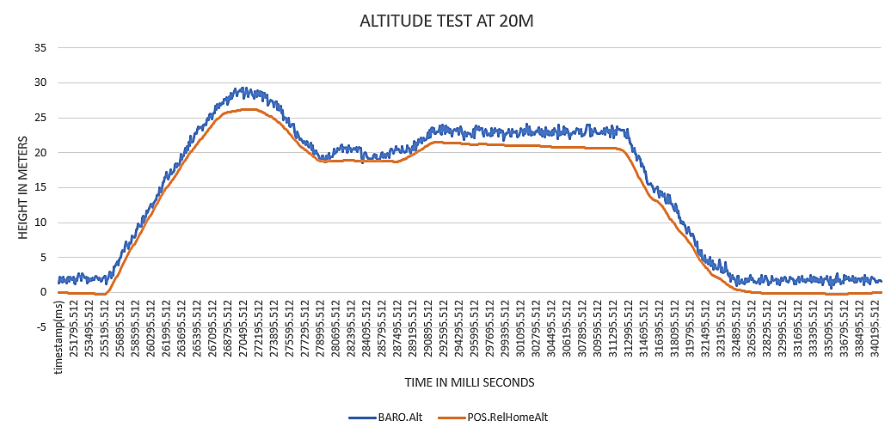

Figure 5.2 Altitude test at 20m

From the above test results it can be conclude that, as the altitude increases the standard deviation also increases, because of the air turbulence, decrease in air pressure which decreases sensor accuracy.

### 5.1.2 Stability Test

In the stability test we have to check the gyroscope stability, so that the drone can balance and adjust the speed according to the gyroscopic error. In this test we will see the gyroscope stability at 10m altitude and 20m altitude and plot the graph for the acceleration along X, Y, Z axis.

The feasible range of acceleration along X, Y, Z axis’s are 0-3m/s2, 0-3.3m/s2, 5-15 3m/s2. The standard deviation is calculated for each of the axis.

This test is performed at two different altitudes at 10m and 20m, at a constant wind speed of 13kmph

**Case 1: Position hold test 10m Altitude**

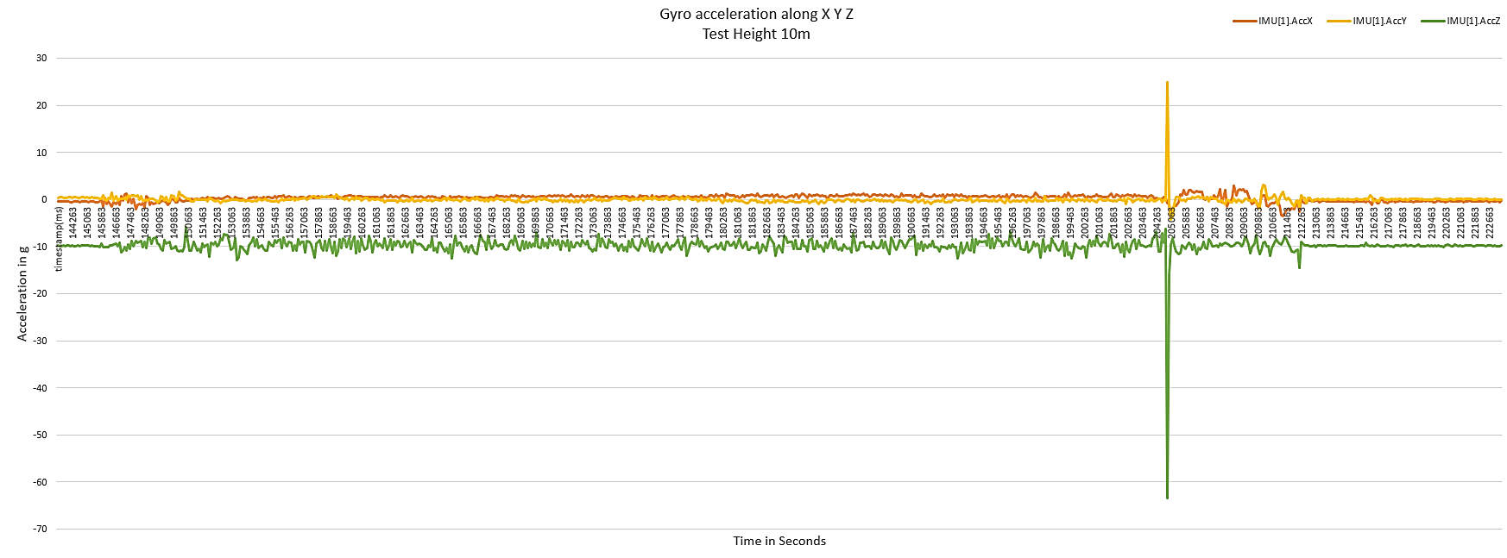

Figure 5.3 Position hold test - 10m Altitude

From the above graph it can be seen that the average X-axis acceleration is 0.323m/s2, Y-axis acceleration is -0.0173 m/s2, Z-axis acceleration is -9.8 3m/s2.

The standard deviation across X axis, Y axis, Z axis are 0.71, 0.98, 2.12.

**Case 2: Position hold test 20m Altitude**

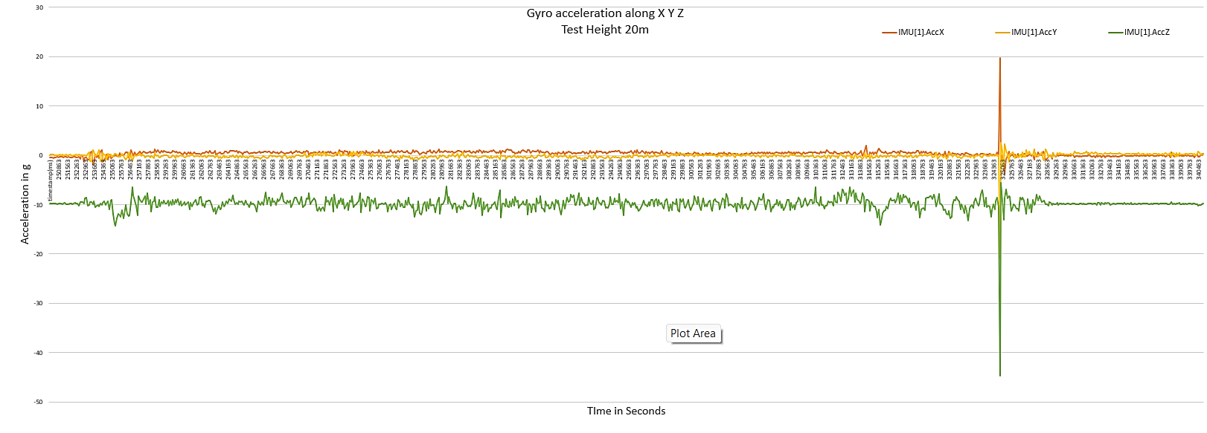

Figure 5.4 Position hold test - 20m Altitude

From the above graph it can be seen that the average X-axis acceleration is 0.373m/s2, Y-axis acceleration is -0.1063m/s2, Z-axis acceleration is -9.84 3m/s2.

The standard deviation across X axis, Y axis, Z axis are 0.78, 0.77, 1.53.

From the above observations, it can be concluded that the GPS position or the stability does hold at any point of altitude within the range.

### 5.1.3 Speed test

An UAV speed test is done in stabilize mode, where it is accelerated at maximum velocity. The quadcopter is initialized in loiter mode and then after turned into SwB2- SwC3 stabilize mode.

The maximum set ground speed of the quadcopter is 10m/s where it can be increased in the mission planner application.

The UAV velocity is dependent on the environment wind velocity, if the external wind velocity is high then the flight controller takes time to settle the oscillations and stabilize the drone.

At higher altitude the drone speed remains same but the stability will be reduced.

This test is done at full throttle.

**Case 1: Speed Test At 10m Altitude**

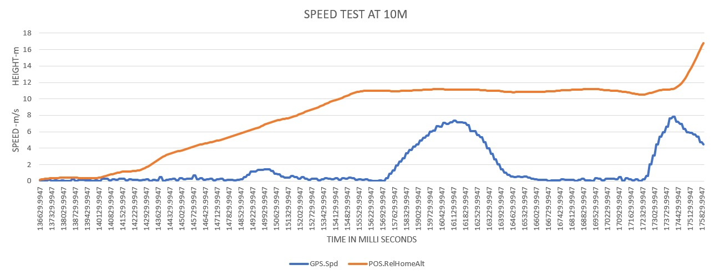

Figure 5.5 Speed Test At 10m Altitude

In the first test the maximum velocity reached by the drone is 7.80 m/s, Average velocity is 2.82 m/s.

**Case 2: Speed Test At 20m Altitude**

In the 20m test the maximum velocity reached by the drone is 7.60 m/s, Average velocity is 2.17 m/s.

From the observations it can be conclude that, as speed of the drone is dependent on the altitude and also stability. Because as the altitude increases the air density decreases which means the propellers have to spin faster to generate the required amount of air downwards to hover, due to the higher RPM the flight controller will difficulty to find a stable point.

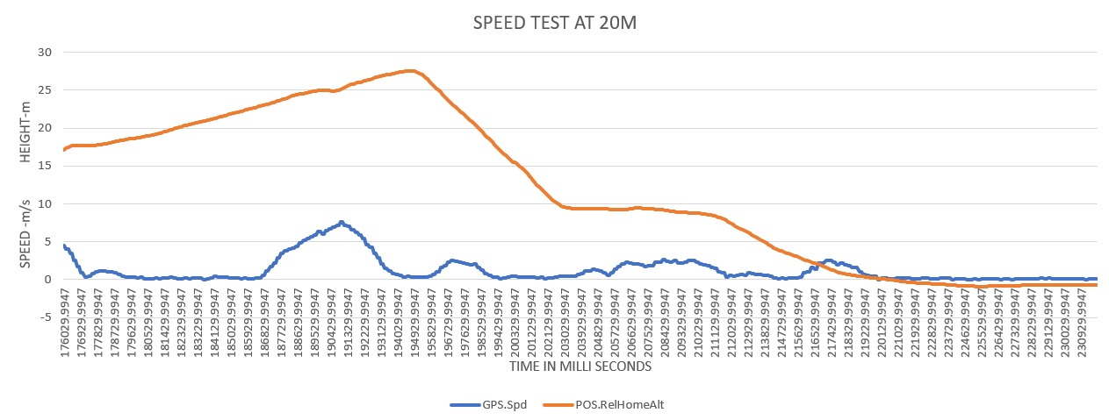

Figure 5.6 Speed Test At 20m Altitude

### Payload Test

Payload test of the UAV is done to determine the maximum weight it can carry. To perform the test the payloads are attached to the bottom of the UAV. The payload weights for the series of the tests are 250g, 300g, 500g

**Max payload Calculations**

When the thrust is equal to the exact weight of the drone, then the drone is in equilibrium point to hover. For a conventional drone, the thrust should be twice of the weight to obtain flight i.e, thrust to weight ratio is 2:1.For a drone of total weight 1500g including battery, the minimum thrust produced should be 3000g to achieve flight. But the total drone thrust is 3200g.

**Case 1: Payload weight - 500g**

Let’s add 500g to the drone, then the total weight should be 2000g, but the thrust produced is 3200g, the additional thrust required is 800g. so the thrust to weight ratio will decrease to 1.6:1 drone will not able to fly.

**Case 2: Payload weight - 300g**

When 300g added to the drone, then the total weight should be 1800g, but the thrust produced is 3200g, the additional thrust required is 400g. so the thrust to weight ratio is decreased to 1.77:1 drone will achieve partial fly.

**Case 3: Payload weight - 250g**

When 250g added to the drone, then the total weight should be 1750g, but the thrust produced is 3200g, the additional thrust required is 300g. so the thrust to weight ratio is 1.82:1 drone will achieve fly but will not able to fly in full thrust.

**Test observation**

The below test is done in open environment where the wind speed is 11km/h. Payload test at 500g is done in the first try as to test the maximum allowable weight drone can carry. From the graph in the Figure 5.7, the attitude deviation is 0.82m but the in full thrust it reached 3.56m and immediately descended to the ground. From the graph in Figure 5.8, the drone achieved 5.29 at 75% of the throttle when payload of 300g is added. Due to loosen payload the deviation is higher.

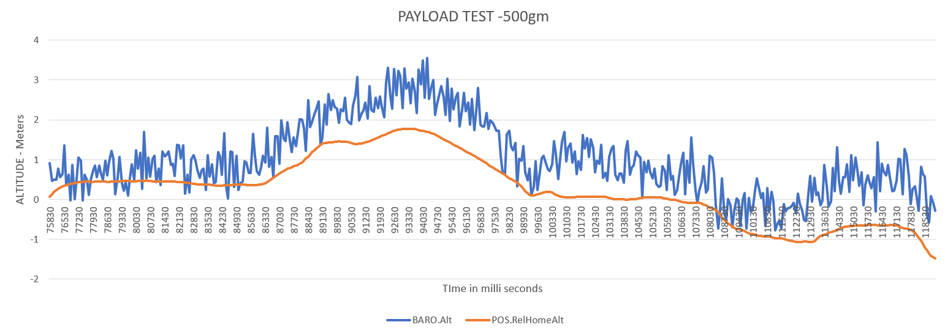

Figure 5.7 Payload test 500g

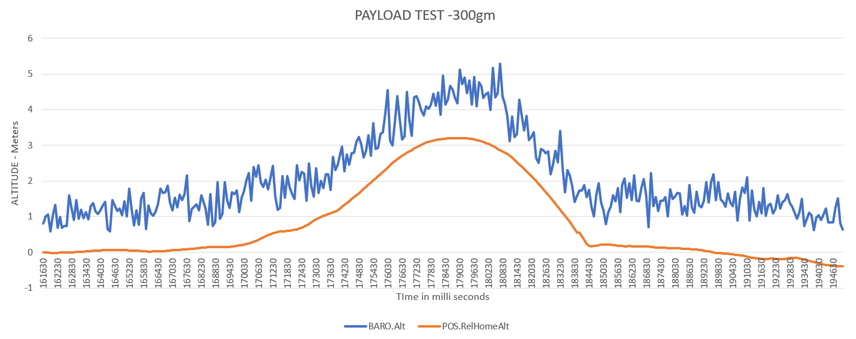

Figure 5.8 Payload test 300g

From the graph in Figure 5.9, the observation of drone achieved 12.03m of altitude at 75% throttle when payload of 250g is added.

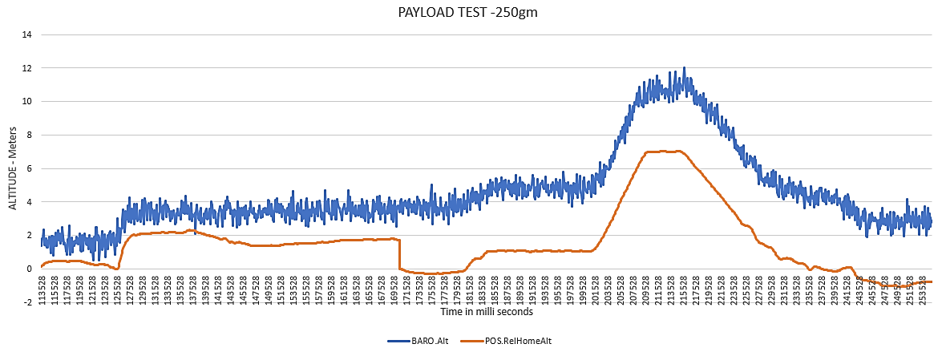

Figure 5.9 Payload test 250g

The analysis shows that payload below 250g is more feasible to lift by the drone to achieve altitude and stability with lower deviation.

## 5.2 Path tests at the Location

The objective of the path test. This could involve analysing the drone's performance in different flight modes, checking the precision of waypoint navigation, or determining how well it can follow a predetermined path.

The waypoint coordinates that make the path. Waypoints are precise geographical places that the drone will successively navigate to.

The path test is done at the college location where the drone should follow the predefined coordinates (Waypoints) the path setup is done in the outline of the football ground located. First the mission planner software is connected to the drone with the telemetry communication device. After the GPS value is locked then the waypoints are selected with the starting home-point at the takeoff point.

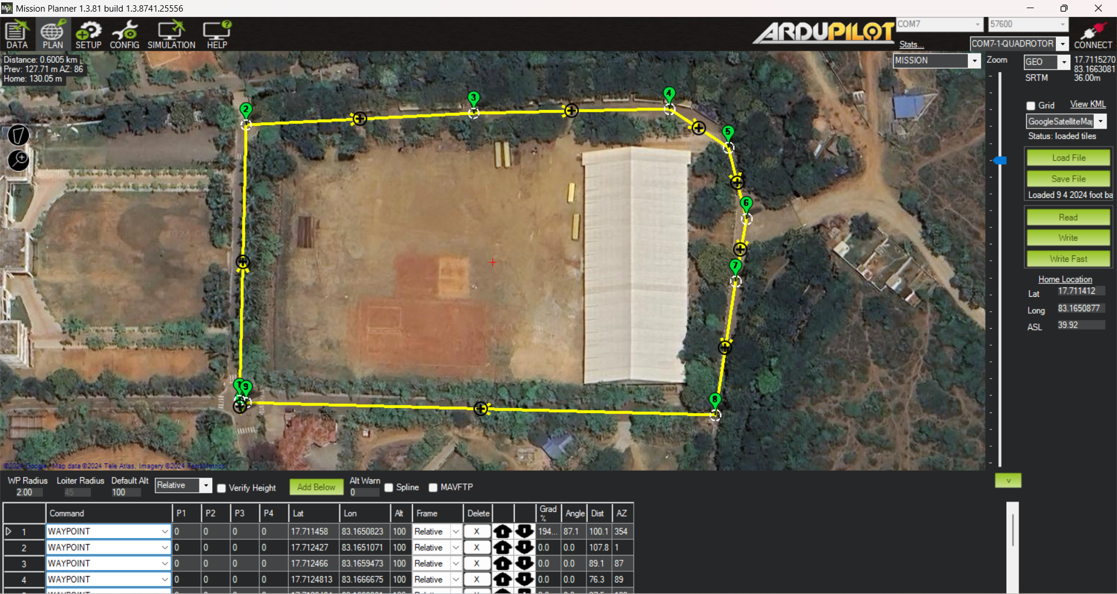

Figure 5.10 Way point Pattern

In the above Figure 5.10 the red box includes the load file and save file which are the features for saving and loading the predefined wave point path each wave point can be modified again when required The first waypoint is selected as take-off and the last one as land or RTL The yellow lines with location symbol on it is the path selected in the above figure.

The yellow box includes the read, write and write fast options, the write option is selected for uploading the wave points into the flight controller using MAV link through communication device telemetry.

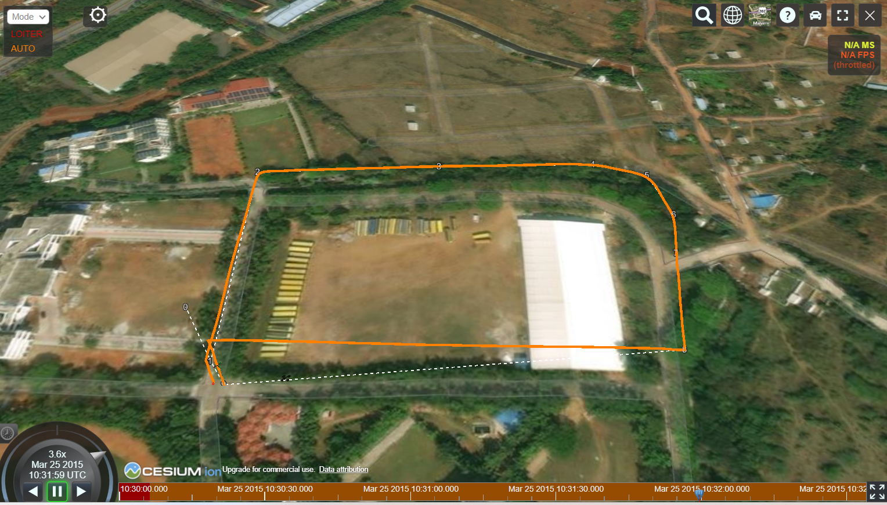

Figure 5.11 3D view drone flight path

Figure 5.11 represents the 3d Drone flight path in which drone has followed according to the wave points uploaded.

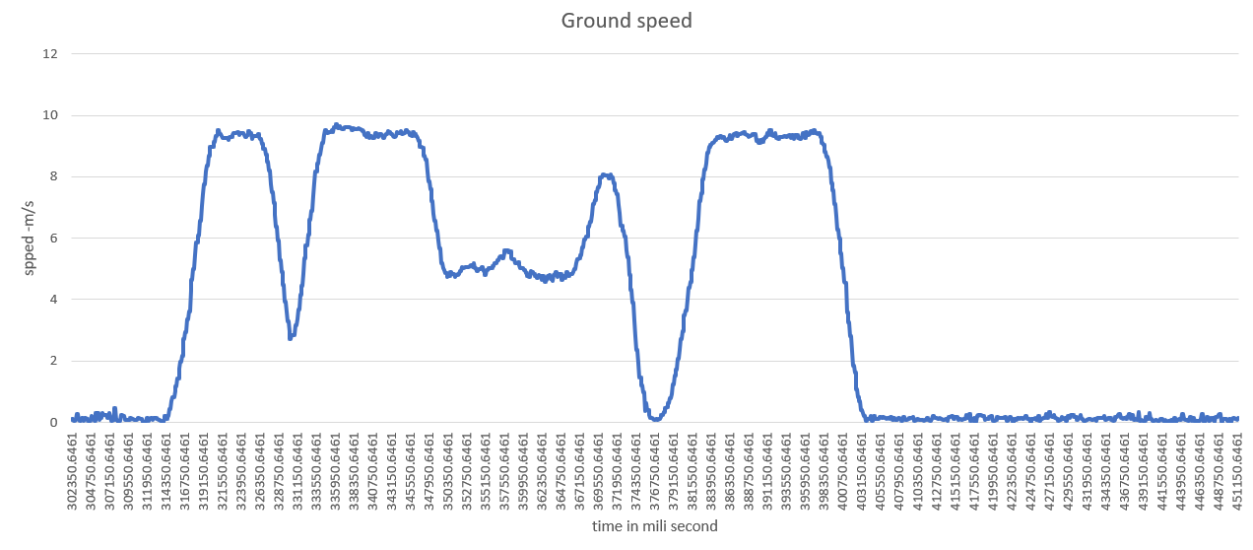

Figure 5.12 Ground speed graph for path test

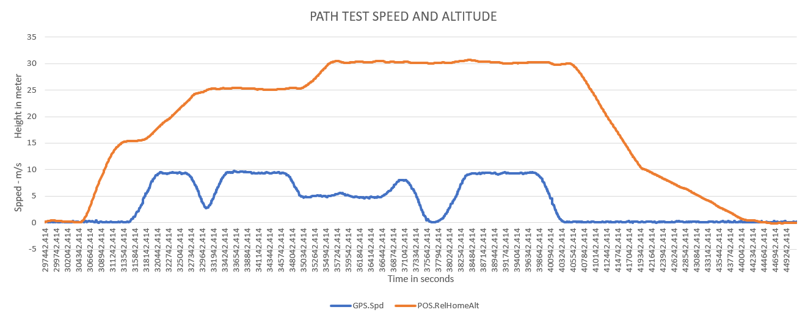

Figure 5.13 Speed and Altitude graph of path test

In the path test the maximum ground speed achieved by the UAV is 9.716 meter per second and the maximum height reached is 30 .67 meters these results are observed from the graph in the figure 34. Whereas the average speed of the drone is 4m/s the total time taken for the Quadcopter to Fly all the path is 2.15 minutes.

At the moment of test the observed wind speed is 23 km/h and the temperature is around 38o centigrade.

The predefined least and highest attitudes are 15 meters and 30 meters, these are set with a precautionary intension of safety not to damage the UAV.

# Conclusion and Discussions

## 6.1 Conclusion

The autonomous surveillance drone represents a major breakthrough in aerial monitoring. We have demonstrated the drone compatibility for various environmental conditions and operational requirements by extensive testing, which includes stability, speed, payload, and Altitude hold tests at altitudes of 10 and 20 meters.

From the stability test, it can be seen that drone could stay in a balanced firm position even in difficult weather or in busy airspaces with a negligible deviation, which guarantee’s smooth operation during surveillance missions.

The speed test concludes that, speed does not change much with altitude. But in order to keep that speed up, stability must be maintained. In addition to facilitating smooth flight, stability is essential for enabling prompt reactions to changing circumstances which allow quick response to dynamic situations.

From the altitude hold test, which was carried out at a height of 10 and 20 meters, identified the drone's superior precision in controlling altitude. This feature is essential for taking detailed aerial photos and carrying out accurate surveillance missions. The drone guarantees clear and consistent capture of every detail of the subject or scenery it is monitoring by precisely maintaining a steady altitude.

The payload test was an essential means of verifying that the drone was able to carry and operate a variety of surveillance equipment and other devices for a range of applications. This effective validation illustrates the drone's adaptability and usefulness and shows that it can be used for a variety of purposes other than just aerial observation.

Overall, the combination of advanced flight control systems and thorough environmental compatibility testing positions, this surveillance drone is a efficient tool for autonomous aerial monitoring, promising enhanced capabilities and reliability in surveillance applications.

## 6.2 Future Scope

The future scope for our surveillance drone are listed below:

**Enhancing Surveillance Capabilities:** Enhancing high resolution camera, thermal imaging, night vision, and AI-powered image processing. These enhancements would allow for more effective monitoring of large areas and improved identification of objects.

**Improve Sensor Integration:** Improving sensor integration using Lidar and ultra sonic sensors to drone can improve the safety, security and obstacles avoiding capability.

**Swarm Technology:** This development in quadcopters enhances the field of search and surveillance by allowing multiple drones to operate cooperatively.

# References

|  |  |
| --- | --- |
| [1] | P. M. a. R. S. S. Bouabdallah, “Design and control of an indoor micro quadrotor,” *IEEE,* vol. Vol.5, no. doi: 10.1109/ROBOT.2004.1302409, pp. 4393-4398, 2004. |
| [2] | A. A. M. Hassanalian, ““Classifications, applications, and design challenges of drones: A review, Progress in Aerospace Sciences”,” *ELSEVIER,* no. https://doi.org/10.1016/j.paerosci.2017.04.003.. |
| [3] | S. &. N. A. &. S. R. Bouabdallah, “PID vs LQ Control Techniques Applied to an Indoor Micro Quadrotor,” *IEEE,* vol. VOL. 3, no. 10.1109/IROS.2004.1389776., pp. 2451 -2456, 2004. |
| [4] | E. N. K. R. C. a. I. F. A. M. Erdelj, “Help from the Sky: Leveraging UAVs for Disaster Management,” *IEEE,* no. doi: 10.1109/MPRV.2017.11., pp. 24-32, 2017. |
| [5] | P. I. T. M. a. J. M. C. S. Gupte, “A survey of quadrotor Unmanned Aerial Vehicles,” *IEEE,* no. doi: 10.1109/SECon.2012.6196930., pp. 1-6, 2012. |
| [6] | A. &. A. A. &. A. M. &. J. Y. &. B. A. &. K. M. Koubaa, “Micro Air Vehicle Link (MAVlink) in a Nutshell: A Survey,” *IEEE,* no. DOI:10.1109/access.2018.2863237, 2019. |
| [7] | Y.-M. &. Y. J. &. C. B.-M. &. E. Y. &. P. K.-J.   Kwon, “Empirical Analysis of MAVLink Protocol Vulnerability for Unmanned Aerial Vehicles,” *IEEE,* no. Access. DOI:10.1109/access.2018.2863237, 2018. |
| [8] | A. K. a. A. K. S. A. Saha, “FPV drone with GPS used for surveillance in remote areas,” *IEEE,* no. doi: 10.1109/ICRCICN.2017.8234482, pp. 62-67, 2017. |
| [9] | A. U. E. K. a. M. A. Q. Z. Zaheer, “Aerial surveillance system using UAV,” *International Conference on Wireless and Optical Communications Networks (WOCN),* Vols. -, no. doi: https://doi.org/10.1109/WOCN.2016.7759885, pp. -, 2016. |
| [10] | S. Z. a. Z. Z. E. Wang, “Research on Composite Material UAV Low-Cost Avionics System Prototype,” *IEEE,* no. doi: 10.1109/WiCOM.2012.6478650., pp. 1-4, 2012. |
| [11] | D. &. R. d. M. M. &. N. L. &. A. P. &. G. d. S. V. &. F. D. &. S. M. Pereira, “Zigbee Protocol-Based Communication Network for Multi-Unmanned Aerial Vehicle Networks,” *IEEE,* no. IEEE Access DOI:10.1109/ACCESS.2020.2982402, 2020. |